International Day of People with Disabilities 2026 Awards
Nomination Information

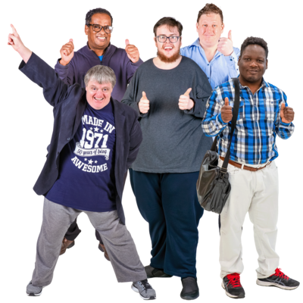 | International Day of People with Disabilities 2026 Awards Ceremony will be held on Thursday 3rd December 2026.
 | This is an important day when we celebrate the people and organisations of the disability community.
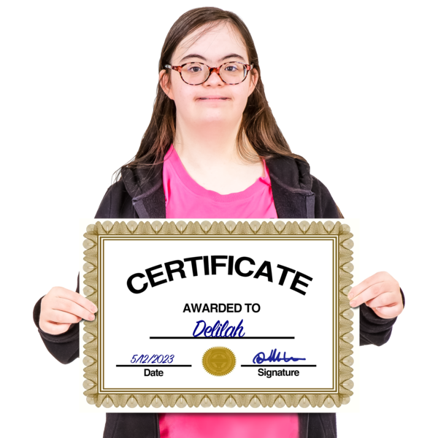 | This year we want to recognise people who are part of the disability community and work every day to make Katherine a better place by giving out awards.

About the awards
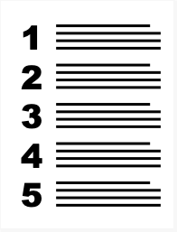 | There will be five awards:
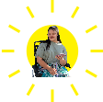 | Outstanding Young Person With Disability - under 25  For a person with disability under 25 who has achieved something special, made a difference to others, or contributed to their community, workplace, education, sport or other area of life  Think about: what they have achieved and the positive impact they have had.
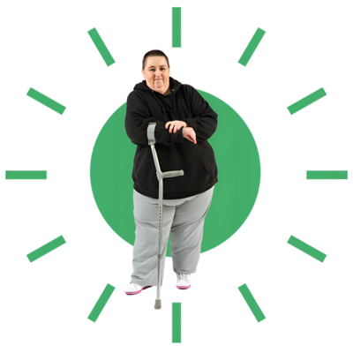 | Outstanding Person With Disability - 25 or over  For a person with disability aged 25 or over who has achieved something special, made a difference to others, or contributed to their community or wider society.  Think about: what they have achieved and the positive impact they have had.
Outstanding Support Person

For someone who goes above and beyond to support a person with disability. They might be a family member, friend, colleague, carer or someone else.

Think about: how they help the person live the life they want, make their own choices and feel valued and supported.

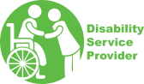 | Outstanding Service Provider  For a service, organisation or business that makes a real difference to people with disability.  Think about: How well they listen to people, meet their individual needs, provide choice, and help people take part in their community and achieve their goals.
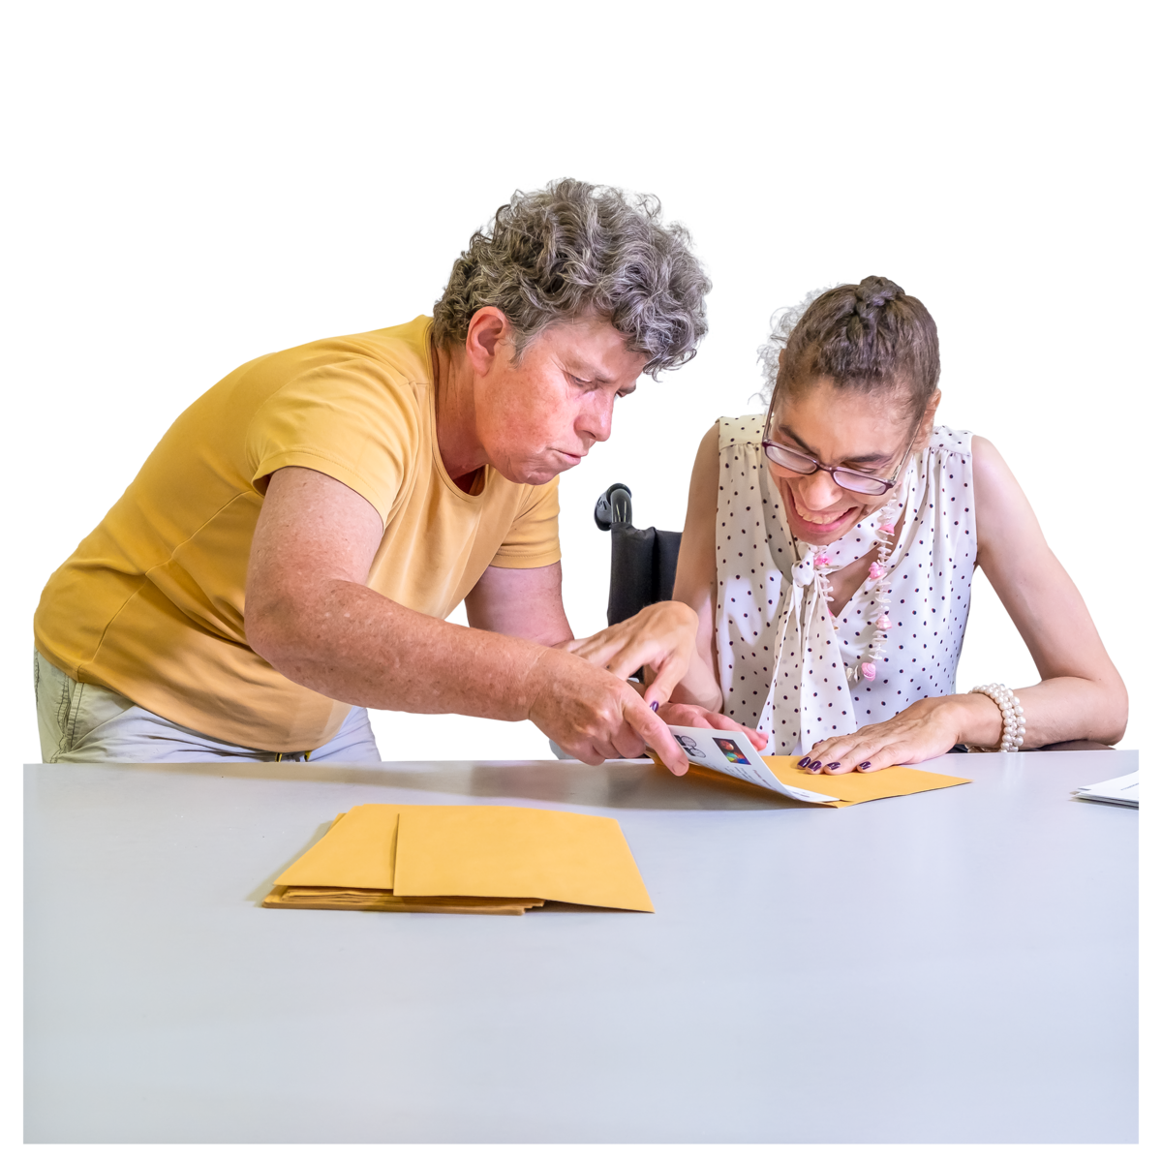 | Excellence in Advocacy & Inclusion  Open to anyone including people with disability, family members, support people, organisations, businesses and services.  Think about: Someone who has helped make things more inclusive for people with disability or helped create positive change.

Rules for the Awards
 | The person you nominate needs to agree to be nominated.
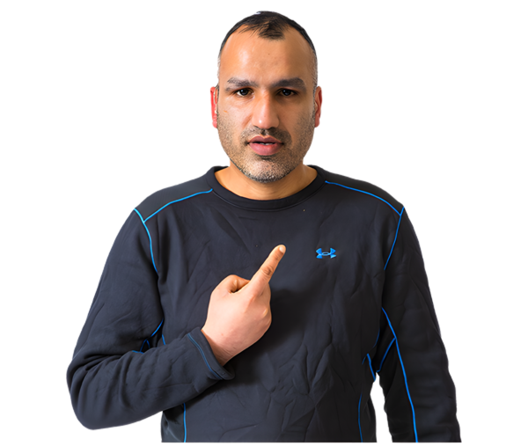 | You can nominate your self
 | The award will be judged by a group of people who:  - are not part of the disability community  - were picked by the Katherine Town Council
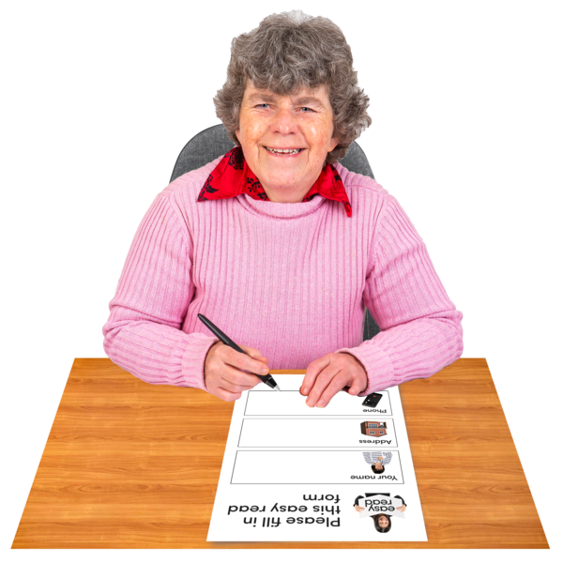  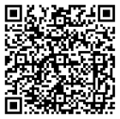  Online nomination | To nominate someone or yourself you can:  📞 Call Council on the phone 08 8972 5500  🙋 In person at the Council office  Civic Centre, 29 Crawford Street  Katherine NT, 0850  🛜 Complete the online form using the QR code  You can ask your support person for help.
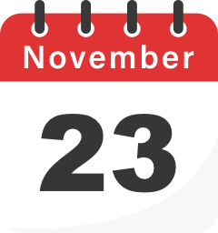 | You need to submit the form by Monday the 23 November 2026.

What happens if I win the award
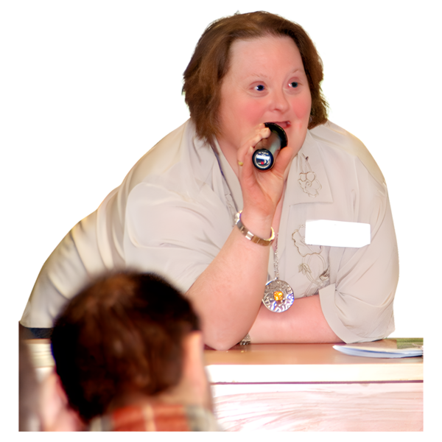 | The awards will be announced on Thursday 3rd December at International Day of People with Disabilities Awards Ceremony.
 | The person who wins will be recognised as having done excellent work and given a certificate.
To find out more you can call our Events team at Katherine Town Council on 08 8972 5500

