

### Attachments to Request for Tender

**for**

**Katherine Town Council**

**ABN** [**47 836 889 865**](http://www.abr.business.gov.au/SearchByAbn.aspx?abn=47836889865)

**regarding**

**Tender 24-05**

### Streetlight Repairs

### and Renewals

**CLOSING**

**2pm, FRIDAY 16th August 2024**

**TENDER BOX KATHERINE CIVIC CENTRE, STUART HIGHWAY, KATHERINE**

**Tender 24-05**

### Streetlight Repairs

### and Renewal

|  |  |
| --- | --- |
| Appendix | Page Number |
| A. Site Maps | **3-5** |
|  |  |

ENQUIRIES:

* Technical nature regarding the work required should be referred to:

Contracts Coordinator 08 8972 5500 or [records@ktc.nt.gov.au](mailto:records@ktc.nt.gov.au)

* Tendering procedures or the like should be referred to:

Manager Governance and Risk 08 8972 5500 or [records@ktc.nt.gov.au](mailto:records@ktc.nt.gov.au)

* Tendering documentation requests to:

Contracts Coordinator 08 8972 5500 or [records@ktc.nt.gov.au](mailto:records@ktc.nt.gov.au)

**Katherine North**

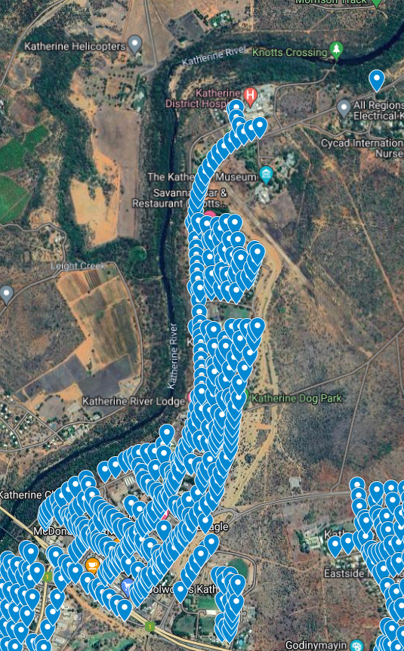

**Katherine East**

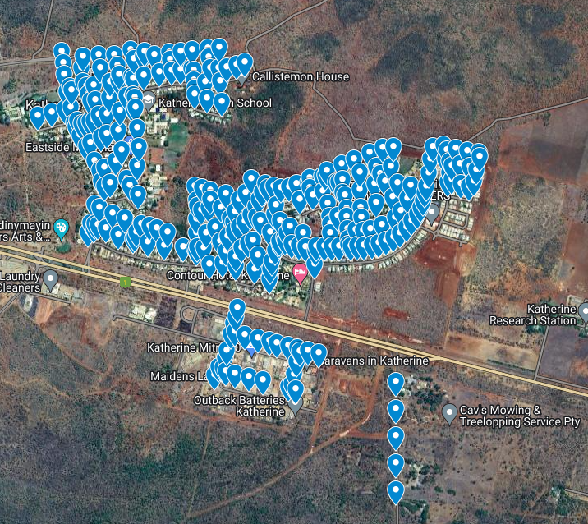

**Katherine South**

