### 

### Attachments to Request for Tender

### for

### Katherine Town Council

### ABN [47 836 889 865](http://www.abr.business.gov.au/SearchByAbn.aspx?abn=47836889865)

### regarding

**Tender 24-06**

### supply of cleaning services

### to all locations

### CLOSING

### **2PM, FRIDAY 16TH AUGUST 2024**

**Tender 24-06**

**supply of cleaning services to all locations**

|  |  |
| --- | --- |
| Appendix | Page Number |
| A. Plan – Katherine Sportsgrounds | **3** |
| B. Plan – Katherine Sportsgrounds Pavilion | **4** |
| C. Plan – Katherine Showgrounds | **5** |
| D. Plan – Katherine Showgrounds Grandstand  Change Rooms And Associated Toilets | **6** |
| E Plan – Katherine Town Council Depot | **7** |
| F Plan – Lindsay Street / Visitor Information Centre Drain | **8** |
| G Plan – Knotts Crossing Car Park Area | **9** |
| H Plan – Hot springs top and bottom area | **10** |

ENQUIRIES:

Technical nature regarding the work required should be referred to:

Contracts Coordinator 08 8972 5500 or records@ktc.nt.gov.au

Tendering procedures or the like should be referred to:

Manager Governance and Risk 08 8972 5500 or records@ktc.nt.gov.au

Tendering documentation requests to:

Contracts Coordinator 08 8972 5500 or records@ktc.nt.gov.au

***APPENDIX A: KATHERINE SPORTSGROUNDS***

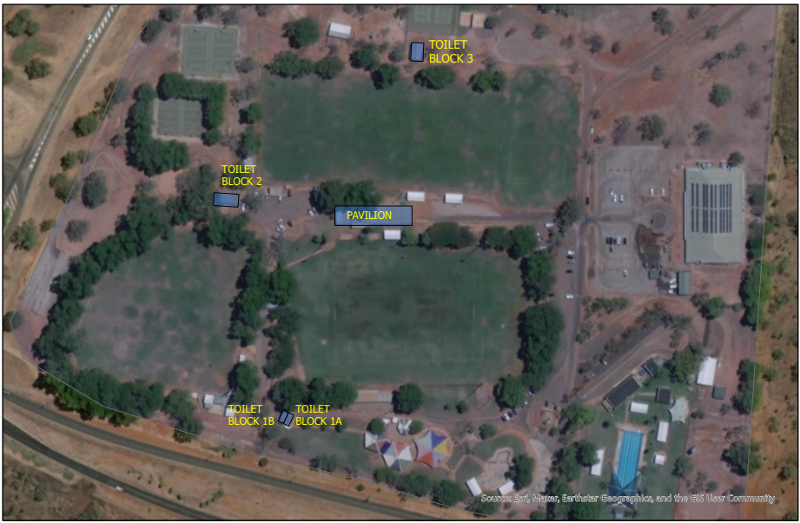

***APPENDIX B: KATHERINE SPORTSGROUNDS - PAVILION***

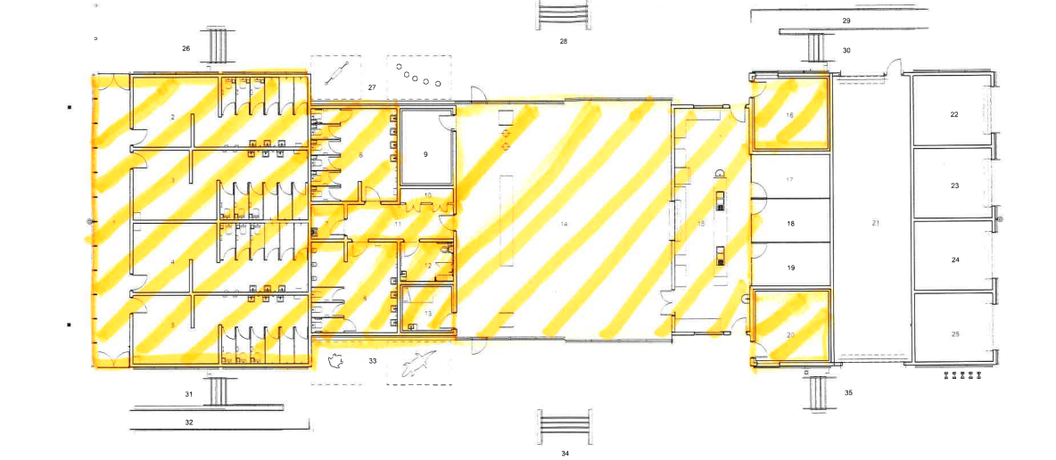

**Areas requiring cleaning services as per Scope of Works ighlighted**

***APPENDIX C: KATHERINE SHOWGROUNDS***

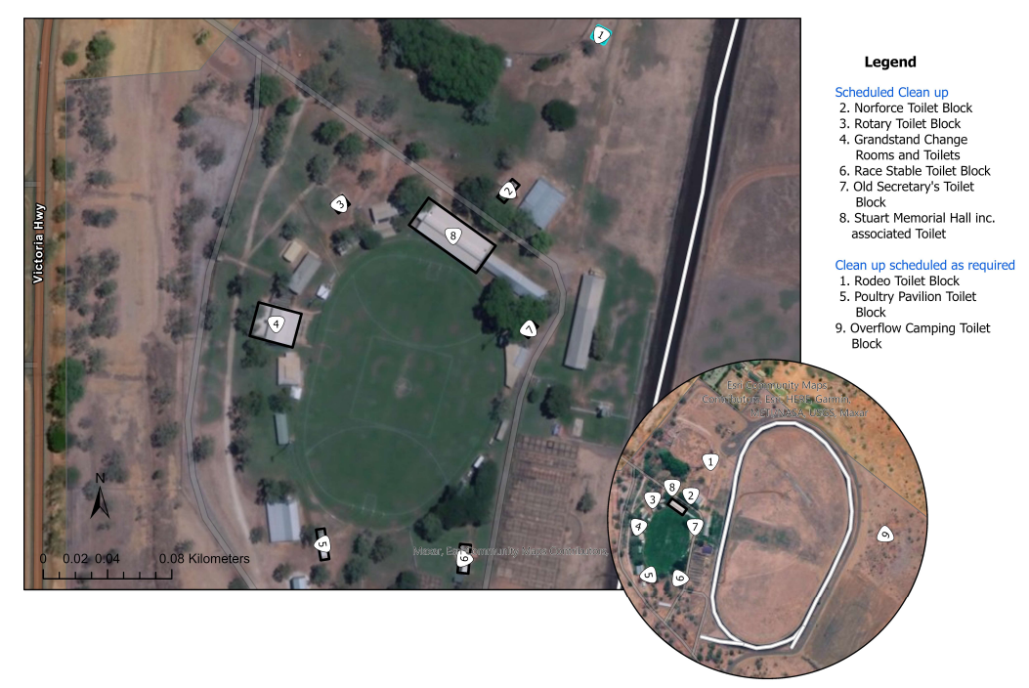

***APPENDIX D: KATHERINE SHOWGROUNDS GRANDSTAND CHANGE ROOMS AND ASSOCIATED TOILETS***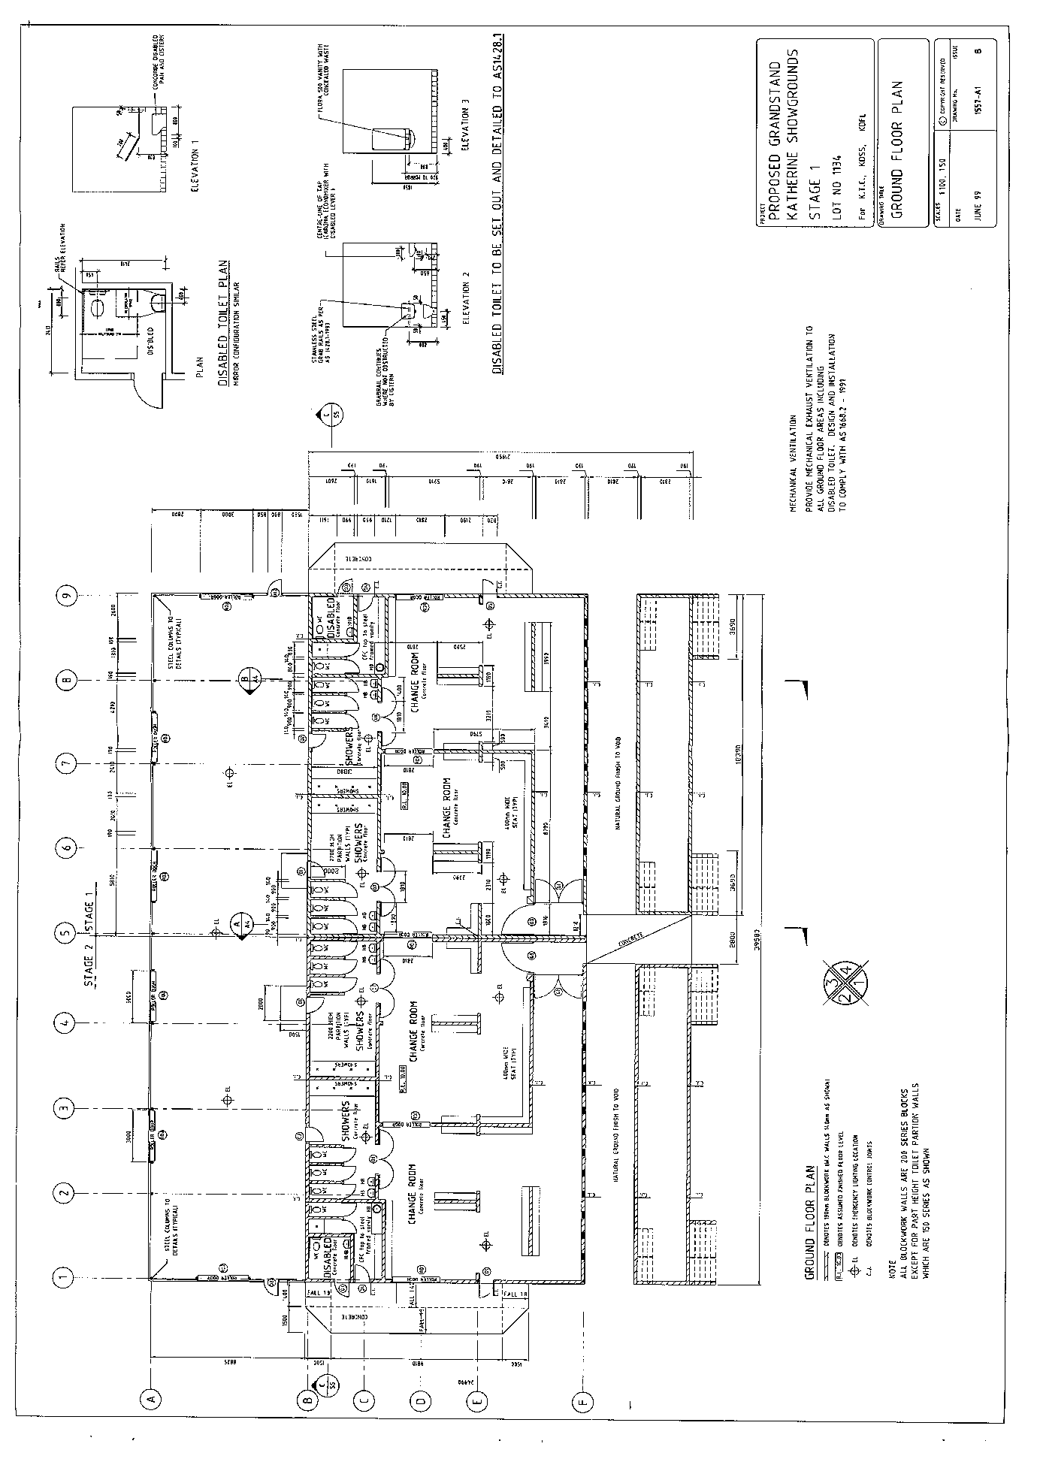

***APPENDIX E: KATHERINE TOWN COUNCIL DEPOT***

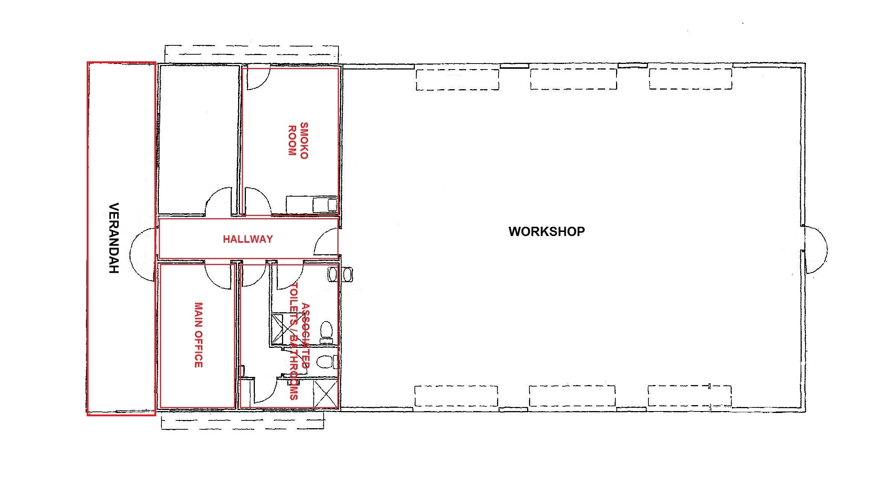

***Appendix f: Lindsay Street / Visitor Information Centre Drain***

***Appendix g: knotts crossing car park area***

***Appendix h: hot springs top and bottom area***

