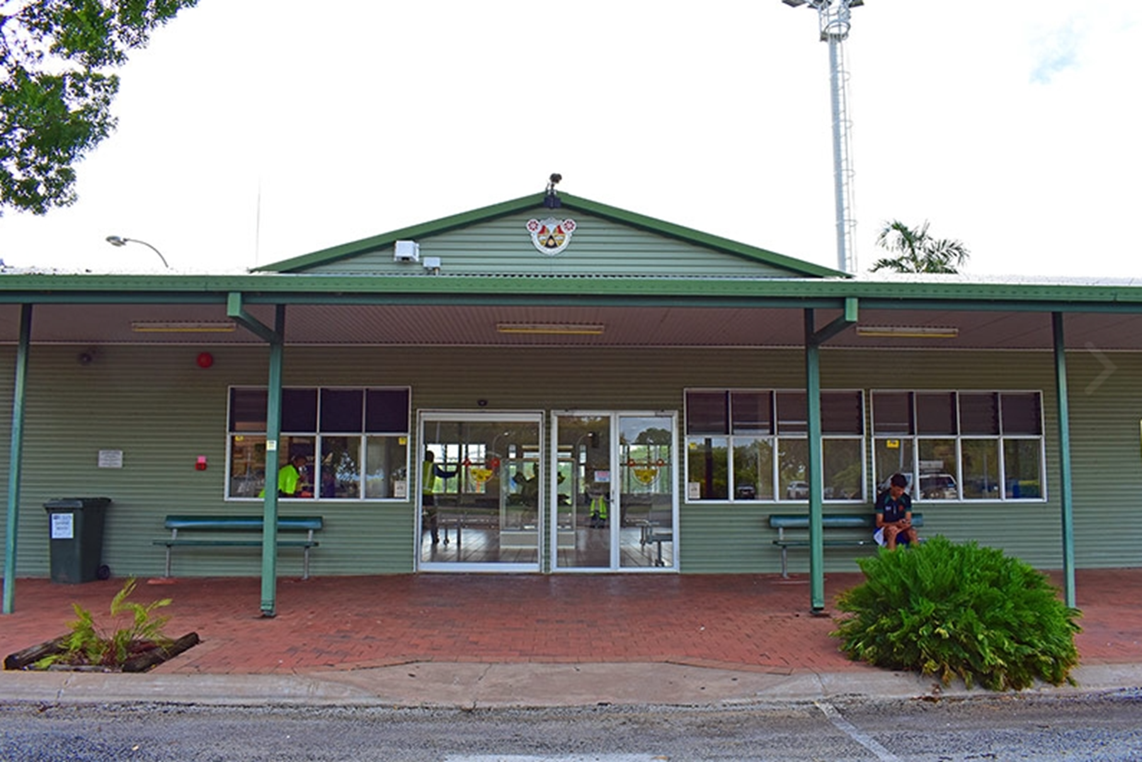
KATHERINE CIVIL AIRPORT
MANAGEMENT SERVICES
AGREEMENT

Contents

Message from the Mayor... 3
1. Introduction 4
2. Process 5
3. The Opportunity – Katherine Civil Airport Operations 6
4. Performance Objectives 8
5. Operational Requirements 10
6. Information Required for Tender Process 15
7. Terms and Conditions 17
Attachments 20

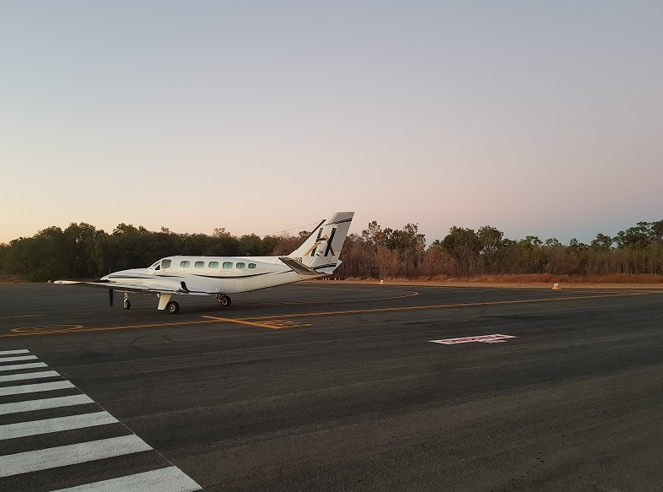
Message from the Mayor...

The Katherine Civil Airport (KCA) is the civilian apron of the RAAF Base Tindal Aerodrome, located approximately 15km south of Katherine, along the Stuart Highway.
The Katherine Town Council has had a long and positive relationship with RAAF Base Tindal since the early 1990s. The Council hold the head lease for the civilian apron.
Katherine Town Council is committed to the professional management of the airport. This key facility is vitally important to Katherine and the surrounding communities, providing logistical support for tourism, industry, counter-disaster and medical emergency response.
An opportunity is available to an appropriately qualified airport management company to operate the Airport on behalf of Council.
As detailed further in this document, significant infrastructure and existing and expanding business arrangements are included in this opportunity.
Katherine Town Council invites all interested parties to submit their vision for the Katherine Civil Airport as part of the tender process.

Elisabeth Clark
Mayor of Katherine

Introduction

Invitations for Professional Airport Management Services

Katherine Town Council (Council) is seeking to develop a Professional Services Agreement for the operational management of the Katherine Civil Airport (KCA) until 30 September 2027, with two further options of ten (10) years each, subject to satisfactory performance.

Council’s objective is to secure professional, industry-specific management of the Katherine Civil Airport, that is cost neutral for Council and delivers a high standard of service to the community, and which builds strong relationships with all stakeholders.

Scope of the Airport Management Service Provider (‘Operator’)

Under the proposed operational Agreement structure, the Operator will be required to provide suitably qualified and experienced Airport Management personnel and systems to operate and maintain KCA and its associated facilities in accordance with high safety standards, operational excellence, industry best practice and quality assurance protocols for the period of the Agreement.

The Operator will be responsible for the overall operations of the KCA and incur all costs associated with the operations and ongoing routine maintenance of the KCA facilities and related fixtures and fittings over the term of the Agreement.

Katherine Civil Airport

Katherine Town Council leases the Civil Airport site of RAAF Base Tindal from the Commonwealth of Australia (Department of Defence). The Lease incorporates a licence to access Runway 14/32, Taxiway Alpha and Taxiway Echo. The Head Lease Provisions, including the boundaries of the Leased Premises and Council’s obligations under the lease, are described in 3.1 of this document.

Katherine Town Council receives income from tenants, landing and parking fees, and other revenue streams arising from the airport operations.

Process

Operational Management Overview

The Katherine Civil Airport currently has no on-site management and daily operations are managed remotely from the Katherine Town Council main office at the Civic Centre, Stuart Highway, Katherine.

Council is seeking a suitable proposal from an appropriately resourced and experienced operator to enter into a Professional Management Services Agreement for the operations of the Katherine Civil Airport.

The commencement date for the Agreement will be based on the selection of the preferred Operator, submission of required documentation, and the receipt by Council of written approval by the Department of Defence as required by the Head Lease.

Council will inform all Respondents of the outcome.

Briefings

Individual briefings for further discussion about the management opportunity are optional. Respondents must contact Council’s Director Infrastructure and Environment, Mr Brendan Pearce (08 8972 5500), to arrange such a briefing. Alternately, Respondents may send an email to records@ktc.nt.gov.au marked as Attention to Brendan Pearce.

Questions

Questions regarding any element of the tendering process will be accepted up until three (3) business days prior to the closing date. All questions are to be addressed in writing to the Director Infrastructure and Environment, Mr Brendan Pearce.

The Opportunity – Katherine Civil Airport Operations

Head Lease Provisions

- The Commonwealth of Australia, through the Department of Defence (DoD), owns all of the land known as ‘RAAF Base Tindal’ which is comprised in NT Portion 3259 on Deposited Plan 86/070 being the land comprised in Certificate of Title Volume 753 Folio 307, the Leased Premises being the portion identified as Portion 5825(A) on survey plan S2000/167.

- RAAF Base Tindal is a Defence aerodrome controlled by DoD as referred to in section 20 of the Civil Aviation Act 1988 (Cth).

- DoD has agreed that Council may use RAAF Base Tindal on the terms and conditions set out in the Lease and the Operating Deed.

- The Council has agreed that:
  - subject to the Lease and Operating Deed it will comply with relevant legislation as if it were the operator of a certified aerodrome under the Civil Aviation Safety Regulations 1998 (Cth); and
  - it will comply with any conditions specified by the Civil Aviation Safety Authority pursuant to section 20 of the Civil Aviation Act 1998 (Cth).

- RAAF Base Tindal comprises three (3) areas being:
  - The Military Area;
  - The Civil Airport Site; and
  - The Licensed Area.

- DoD uses the Military Area as a RAAF base.

- DoD has granted a lease to the Council that expires on 30 September 2027 and Council accepts a lease of the Civil Airport Site on the terms of this lease. Subject to the terms of clause 45 of the lease, two further option periods of ten (10) years each, the first commencing on the day after the expiry of the initial Term and the second commencing on the day after the expiry of the first further term, are available.

- The Licensed Area is used by the parties to this lease and by third parties.

- Operations by civil aircraft traffic are controlled by the requirements and limitations of the Operating Deed relating to the Licensed Area at RAAF Base Tindal.

The Katherine Civil Airport comprises of the following Buildings, Facilities, and Infrastructure Assets

Airport Passenger Facility:
- Check-in kiosks are provided.
- There is a vending machine inside the terminal that returns a per annum site rental.
- Toilets are in good condition. A new septic system is in place and water is potable.
- Airside is accessed by swipe-card through security gates.
- An appraisal has confirmed that asbestos is not present within the terminal building.

Hangars
- There are three established hangars, one of which is property of the Commonwealth and sub-leased as a building, the others are owned by the stakeholders who have a sublease for the land the hangars where the hangars are sited.

Warehouse/ Offices
- This is a large building with multiple offices and storage space. It is currently 90% empty.
- The walls, ceilings and floors are in good condition. Asbestos is confirmed in some building components (report available).

Aprons
- The RPT apron is in fair condition.
- The GA apron is in fair condition.
- The line-marking is faded in parts.

Taxiway Echo
- The taxiway is in very good condition and is maintained by RAAF Base Tindal.
- A pipe culvert runs beneath the taxiway. This is not rated and consequently use of Taxiway Echo is limited to 25,000kg MTOW. Taxiway Echo is the only access to the runway from the KCA and so limits the size of aircraft the airport can service.

Fuel Facility
- The fuel facility is operated by a local agent on behalf of a joint venture between VIVA and BP.
- AVGAS is uplifted from a card-swipe bowser and Jet Al provided from a 16,000-litre truck.

Respondents are encouraged to contact Katherine Town Council to arrange access to inspect the facilities prior to submitting their proposal. Appointments can be arranged by contacting the Operations Manager on (08) 8972 5500 or email records@ktc.nt.gov.au

Performance Objectives

General

The KCA provides a key service to the community and region. Operation of the site need to provide both tangible and intangible beneficial community outcomes that Council consider important to enhance the KCA as part of the Agreement. The on-site presence of the Operator is central to optimising the value of the KCA to the community and minimising risk to Council with the successful Operator demonstrating alignment with Council’s goals:
- To enhance the precinct as user friendly, safe, and inviting space;
- To maximise the economic, social, and cultural benefits to the town and wider community;
- To develop a business model that enables commercial viability for the Operator and a cost neutral or enhanced position for the Council; and,
- To transfer airport maintenance, compliance, and replacement responsibilities/liabilities to the Operator.
These objectives should all be addressed in the submission.

Community engagement, business opportunities and strategic planning

    - Preparation of multiple funding applications on behalf of the Katherine Town Council, including collating letters of support, quotations, and justifications
    - Facilitate and manage tenancies and other commercial arrangements for use of airport facilities and grounds. Ensure customer service delivery is of the highest standard. Optimise community benefits, usage, and revenue to offer the ability to grow the business opportunities
    - Encourage Indigenous participation and provide local training programs and pathways for local workers to become Aerodrome Reporting Officers and Work Safety Officers and ground operations staff
    - Facilitate public art installations and displays by local artists, historical society, and Chamber of Commerce to promote information about local indigenous culture, regional history, tourism, recreation, entertainment, and business opportunities
    - Engage with local indigenous artists to make visible ‘Welcome to Country’ statement
    - Conduct feasibility study of regional air routes and potential to increase accessibility of commercial and domestic flights for residents and businesses in Katherine and surrounding communities
    - Maintain membership to the Airports Association of Australia ("AAA") to enable representation and inclusion to the industry’s peak body of representation on a federal level
    - Actively participate in stakeholder meetings

Aerodrome and facility management

The Operator will provide on-site management and assume responsibility for ongoing maintenance, compliance, and operational matters.

  - Maintenance
- Develop a maintenance plan for both airside and landside facilities. The initial plan will have a basic maintenance regime that will be tailored to improve the overall condition of the KCA.
- As part of the daily inspections, the Airport Manager will ensure that all airport infrastructure, taxiways & apron, work areas, common use areas, equipment and vehicles are monitored for serviceability and presentability. Taxiway and apron lighting will be checked, and globes will be immediately replaced.
- Ensure customers are well looked after and the facilities are kept and maintained in safe and good working order.

  - Aerodrome Regulations and Operations
- Implement advanced management and administrative systems to govern the operation of the airport
- As a certified aerodrome under CASR 139 and MOS 139, an aerodrome must be maintained and operated in accordance with the regulations and the approved Aerodrome Manual. Write an Aerodrome Manual specifically for the existing operation of the airport and define the aerodrome's procedure and processes.
- Manage all facility requirements under the Head Lease arrangements between the Operator, Katherine Town Council, Defence/RAAF, and the facility lessees
- In line with the Operating Deed, ensure the operation is in accordance with this governing document and provide suitably experienced and qualified staff to fulfill duties in line with the operational scope of work outlined in the document.

  - Quality Assurance
- Provide safe, cost-effective services consistent with the Katherine Town Council ’s standards and requirements by the implementation of a Quality Management System, in accordance with the requirements of ISO 9002-1994 Quality Systems Model for Quality Assurance in Production, Installation and Servicing.

  - Client Interface
- The onsite Aerodrome Manager will be the primary contact to the Aerodrome customers and lessees, RAAF and Katherine Town Council and will interface on all the above matters through provision of written reports and attendance to meetings on a regular basis as agreed with and by the Operating Deed.

  - Industry Association
- The Katherine Aerodrome Manager is to commit to at least one Northern Territory Australian Airport Association conference per year.

Operational Requirements

Project Plan

On commencement of the term of the Agreement, the Operator will undertake the following in consultation and handover with the Katherine Town Council as a project plan with key milestones and key performance indicators.
- Meet and introduce the Operator to all applicable stakeholders to present the vision for the KCA.
- Provide timelines and strategy to achieve Project Plan.
- Format reports to be submitted to Katherine Town Council and RAAF at intervals agreed to by applicable stakeholders.
- Handover from Katherine Town Council to Operator of operational responsibility with applicable stakeholder engagement for areas of responsibilities under the KCA contract.
- Write and Implement the Aerodrome Manual with applicable stakeholder engagement.
- Write and Implement a Safety Management System with applicable stakeholder engagement.
- Implement the Drug and Alcohol Management Plan with applicable stakeholder engagement.
- Write aerodrome specific policies with applicable stakeholder engagement for areas of responsibilities under the KCA contract.
- Develop and compile an asset register for areas of responsibilities under the KCA contract.
- Develop and schedule a dedicated maintenance plan for areas of responsibilities under the KCA contract.
- Develop a remediation plan for the Apron areas.
- Provide a summary of priority capital works for operational and strategic improvements that can be developed for funding submissions to government and private enterprise as opportunities present.

Operational Management

The onsite management will undertake all administrative, compliance and regulatory tasks including:
- Record Keeping/ Training Records.
- Provision of required reports to Katherine Town Council and RAAF documentation updates.
- CASA or RAAF inspections and surveillance audits, action plans and close outs DITRDLG requirements/ Audit Actions.
- DAMP Responsibilities (part 99 of MOS 139).
- Emergency Committee Management (in alignment with RAAF).
- Emergency Exercise Planning (in alignment with RAAF).
- Annual Technical Inspection Audit action.
- Fuel Company Requirements (Align with current provider).
- Recording of all aircraft movements and aircraft type and manage all RPT movements as per the Operating Deed.
- Quality Assurance and Quality Control plan.
During the terms of the Agreement, the Operator will be responsible for:
- All costs associated with the daily operation of the airport.
- All statutory fees and charges and outgoings including water, power and sewer.
- Routine maintenance of the airport facilities and infrastructure as agreed with Council.
- Ensuring use of the Airport is always compliant with the terms of the Agreement and CASA regulations.

At the end of the Agreement the Operator will be responsible for making good, including reinstatement of services, fittings, fixtures, and modifications carried out during the Agreement if required.

Airport personnel and routine tasks

    - As per CASA regulations, Katherine Town Council is responsible for the Accountable Manager and the role is delegated to the Director of Infrastructure and Environment.
    - Aerodrome Manager available on call 24/7/365 with applicable annual leave, suitably qualified and experienced and tasked with the operation and maintenance of the KCA and associated facilities.
    - Aerodrome reporting officer/s.
    - Work safety officer/s.
    - Ground handling and security personnel as required.
    - Civil and electrical works for repairs, maintenance, and installations.
    - Compliance and document control to meet Part 139 MOS Standards.
    - Technical, lighting, and electrical inspections.
    - Aerodrome surveys and assessments.
    - Aerodrome equipment supply.
    - Taxiway and apron sweeping and rolling.
    - Taxiway and apron line marking.

Ground’s maintenance including

    - Sweeping taxiway and apron, carparks, and roads.
    - Maintaining fencing.
    - Grass mowing/slashing, trimming trees and maintaining gardens.
    - Picking up rubbish.

Building maintenance including

    - Cleaning.
    - Minor repairs and painting.
    - Test and tag and routine inspections.

Regulatory compliance - providing documentation for regulatory compliance including:

    - Maintaining currency of documents in line with Certified Aerodrome requirements.
    - Aerodrome Manuals.
    - Drug and Alcohol Management Plans (DAMP).
    - Safety Management Systems (SMS).
    - Risk Management Plans (RMP).
    - Emergency Response Plans (ERP).
    - Emergency Preparedness Plans (EPP).
    - Change Management Plans (CMP).
    - Wildlife Hazard Management Plans (WHMP) CASR 175.
    - Aeronautical Information Products (AIP).
    - Method of Works Plan (MOWP).
    - Transport Security Plans (TSP).
    - Aviation Security Identification Cards (ASIC) issuing body.

Financial Agreement and Incentives

Council is seeking to partner with an Operator to grow the airport and realise its potential over the long-term, and this includes actions such as:
- investing time and other resources into the development and implementation of compliance related items to ensure the KCA meets the standards and is correctly operated and compliant with Civil Aerodrome Aviation Standards as per the regulatory requirements of Part 139 MOS;
- making provisions for future growth to support Katherine, its people, and its businesses;
- exhausting all available funding avenues to support the KCA and lobbying government and private avenues to assist with the overall cost and ongoing maintenance of the KCA to ensure it remains financially viable to continue to support the Katherine community;
- presenting Council with regular reports detailing the operations and status of the KCA outlining the health of the KCA with compliance, financial, growth opportunities, external funding, investments and grant, and customer feedback;
- engaging in discussions with the Katherine Town Council about investment strategies to add value to the KCA and forecasting budget provisions for the facility.

The Tenderer must submit a Schedule of Rates that proposes an annual fee (to be paid in monthly instalments) for the provision of Management Services for the Katherine Civil Airport.

In accordance with clause 3.6 Price Adjustment in the Conditions of Contractv5.4:
- Contract Rates shall be firm for the first twelve (12) months and thereafter subject to price adjustment.
- The adjustment shall be undertaken at either the date allowed for in the Contract or the Contractor’s application date, whichever is the latter. Adjustment shall apply until the next adjustment date.
- The relevant statistics used for annual calculation of price adjustment shall be drawn from the most recent Australian Bureau of Statistics catalogue number 6401.0 All Groups – Darwin, available from www.abs.gov.au or by telephoning 1300 135 070 and selecting option 2.

The Tenderer must develop and submit to Council the Project Plan (section 5.1) within six (6) months of commencement of the Agreement. The Tenderer must submit in the Schedule of Rates a once-off fee for this item. The fee will be paid in two (2) equal instalments, with the first instalment due on commencement of the Agreement and the second payment due on Council’s acceptance of the Project Plan.

Council proposes that the Operator receives additional annual payments as a business development incentive. The structure and terms of this payment will be negotiated with the preferred Tenderer and based on increases in rolling the 3-year average annual net Operating Revenue that are achieved during the period of the Agreement.

Other Uses

Council is open to the Airport being utilised for complementary purposes aligned with its objectives. However, uses that are inconsistent with Council’s objectives or those that do not complement or support preferred community outcomes will not be supported. Respondents are to include all proposed alternative uses as part of the submission. Consideration of alternative uses will also be subject to any other permissions or regulatory approvals for the site.

Agreement Term

Council is offering an Agreement for an initial term ending 30 September 2027.
Subject to satisfactorily meeting the requirements of this initial term, two additional terms of ten (10) years each, may be available. The first additional term will commence on the day after the expiry of the initial term, and the second additional term will commence on the day after the expiry of the first additional term. This is to enable the Operator to maximise return on investment and deliver benefits in line with Council’s objectives, noting the significant long-term strategic planning and asset renewal program required to sustain the KCA and associated enterprises.

Agreement Boundary

The proposed Agreement boundary is shown in Attachment One.

Approvals

The Operator will be responsible for obtaining all approvals required in order undertake airport operations.

Information Required for Tender Process

To enable Council to assess submissions, each Respondent is required to complete the T22-06 Management Services for Katherine Civil Airport Response Schedules.
The Response Schedules sets out the form and content required to be submitted in each submission. Respondents are strongly advised to observe the content and guidelines included in the response schedule.
Attachments with additional information may be included with submissions.

Evaluation Criteria

Council will use the following criteria to evaluate submissions:
  - Experience and track record in similar operation management;
  - Financial capability and capacity;
  - Organisational capability and capacity;
  - KCA vision including social, cultural, and recreational benefits to the town and/or the region; and
  - Sustainability and financial arrangements.
Provided below, are further details of each evaluation criterion that will be used by Council in its evaluation of submissions.

Experience and Track Record in similar airport operations management
Respondents are to clearly outline their track record and experience in managing and operating operations or related of comparable size and nature. Specifically, Respondents should provide examples of operations and document notable achievements and successes in the last five years.

Financial Capability and Capacity
Respondents should provide evidence of their financial capability and capacity to meet the obligations of the Agreement term and their ability to support the daily operations and maintenance of the site as required under the Agreement.

Organisational Capability and Capacity
Respondents should provide evidence of their organisational capability and capacity to meet the obligations of the Agreement term and their ability to manage the daily operations and maintenance of the site to a high standard as required under the Agreement.

Vision and Local Benefit
Respondents should explain their vision for the Katherine Civil Airport and provide details of how and the extent to which the vision aligns with Katherine Town Council objectives. Respondents should clarify any proposed variations to Council’s preferences.

Sustainability and Financial Arrangements
In accordance with the Scope of Works – Management Services for Katherine Civil Airport, Section 5.7 Financial Agreement and Incentives, Council seeks to establish a management model and financial arrangement that enables commercial viability of the Management Services Provider (Operator) and a cost neutral position for Council in relation to the Katherine Civil Airport. Respondents should provide evidence that demonstrates their capability and capacity to develop and implement strategic and business plans.

Selection Process

Council will review and assess each submission in accordance with the following process:
Step 1: Initial review of each response to confirm that all required components of the submission are present and in a form capable of evaluation.
Step 2: Detail assessment and review of specific content of the responses against each of the evaluation criteria to rank responses. (NOTE: Katherine Town Council may seek clarification or further details from Respondents).
Step 3: Katherine Town Council to enter in direct negotiations with the preferred Respondent, confirming Agreement provisions including terms and financial contributions payable.
Step 4: Katherine Town Council will liaise with RAAF/DoD to obtain approval of the preferred Respondent.
Step 5: Confirmation of Agreement awarded by Katherine Town Council Resolution.

Evaluation Process

- Council will not be bound to engage any Respondent or review any submissions that does not conform to the requirements set out in the tender documentation.
- The Respondents acknowledge that Council is not bound to accept any submission to this tender and may terminate the process at any time.
- The receipt of a submission does not give rise to any contract governing, or in any way concerning, the process, or any aspect of the process. Council expressly disclaims any intention to enter into such a contract.

Terms and Conditions

Lodgement Details

The Respondent must provide Council with:

One hard copy of the submission in a sealed envelope marked “Confidential – Katherine Civil Airport Management Services”

- Via the Tender Box at Katherine Town Council Civic Centre 24 Stuart Highway, Katherine NT 0850
Or
- Via prepaid post to PO Box 1071, Katherine NT 0851

Or

One electronic copy of its submission online

- Via records@ktc.nt.gov.au
Or
- Via Tenderlink online portal

Closing Date and Time

The closing time for submissions is 2.00pm (Central Standard Time) on Tuesday 16 November 2021.
Katherine Town Council will not consider late submissions.

Costs to be borne by Respondents

Neither Katherine Town Council nor any other agency nor their respective officers will be responsible for any costs or expenses incurred by any Respondent in preparing or lodging a submission or in complying with the tendering process.

Confidentially and Propriety Information

Subject to the terms of this tender process, Council will hold all submissions in confidence in so far as the law permits.
The submissions will become Council’s property.
Without limitation, each Respondent authorises Katherine Town Council to use and reproduce the whole or any portion of the Respondent’s submission for the purposes of evaluation.
Any personal information collected as part of the process will be handled in accordance with the Privacy Act.

Canvasing

The Respondent, its employees and consultants, must not approach, or request any other person to approach, any Elected Member, member of Katherine Town Council’s staff or consultant engaged by Council:
- to solicit support for its submission; or
- otherwise seek to influence the outcome of this tender process.
The Respondent will direct all communications during this process as per section 2.3 Questions.
If a Respondent breaches this clause Katherine Town Council may, in its sole discretion, disqualify the Respondent from participating in the tender process.

Conflict of Interest

Respondents must declare to Katherine Town Council any direct or indirect conflict of interest in respect of the Council or this process.

Public Statements

A Respondent must not make any public statement in relation to this process and must refer all enquiries from the media to Katherine Town Council.

Change in Circumstance

Each Respondent must inform Katherine Town Council promptly in writing of any material change to any of the information contained in the Respondent’s submission, and of any material change which may affect the truth, completeness or accuracy of any information provided in, or in connection with, the submission.

Other Rights

Without limitation, Council reserves the right, in its absolute discretion at any stage of the process, to:
- Require additional information from a respondent;
- Check submissions for error and omissions and, by agreement with a Respondent, otherwise amend the submission of the Respondent to remedy the effect of any errors or omission;
- Change the timing of the process and the timing or basis on which submissions are required or accepted;
- Rely on publicly available information relating to the Respondents as part of the process; and
- Publish the names of Respondents.

Attachments

      - KATHERINE CIVIL AIRPORT TENANCY AND RENTAL REVENUE DATA PER ANNUM

      - KATHERINE CIVIL AIRPORT LEASED AREA

      - KATHERINE CIVIL AIRPORT AERIAL VIEW

      - KATHERINE CIVIL AIRPORT TERMINAL BUILDING LAYOUT

      - KATHERINE CIVIL AIRPORT ANCILLARY BUILDING AND WORKSHOP LAYOUT

      - SUPPLEMENTARY INFORMATION
REFERENCES (ADDENDA)
*Appendix 1 Katherine Civil Airport General User Conditions
*Appendix 2 Katherine Town Council’s Schedule of Fees and Charges 2021/2022
*Appendix 3 - Warehouse - Building Compliance Report
*Appendix 4 - Katherine Civil Airport Asbestos Register
*Appendix 5 - Tindal Aerodrome - Apron Pavement Assessment
*Appendix 6 - KCA Serviceability Inspection Check List
*Appendix 7 - KCA Tenancy Schedule - Template

- KATHERINE CIVIL AIRPORT TENANCY AND RENTAL REVENUE DATA PER ANNUM

KATHERINE CIVIL AIRPORT TENANCY AND RENTAL DATA – March 2021
Lease | Tenant | Area in the airport | Rate $/unit |  | Qty | Total $ | $/mth | $/P.A.
1 x 18 mths | Tenant 1 | Water/Sewerage | $1.00 | ea | 1 | $1.00
 |  | Terminal - Baggage Handling Area | $50.00 | ea | 1 | $50.00
 |  | Terminal - Office & Storage | $20.00 | m2 | 4 | $80.00
 |  | Terminal - Electricity | $4.00 | ea | 1 | $4.00
 |  | Storage - Baggage Handling Area | $50.00 | ea | 1 | $50.00
 |  | Storage - Airside Area | $50.00 | ea | 1 | $50.00 | $235.00 | $2,820.00
Exp 2024  Renew 2 x 5 yrs | Tenant 2 | Water/Sewerage | $1.00 | ea | 1 | $1.00
 |  | Terminal - Counters & Storage | $200.00 | ea | 1 | $200.00
 |  | Terminal - Baggage Handling Area | $50.00 | ea | 1 | $50.00
 |  | Terminal - Electricity | $4.00 | ea | 1 | $4.00
 |  | Hangar | $2.10 | m² | 495 | $1,039.50
 |  | Hard Stand | $1.38 | m² | 585 | $807.30
 |  | Metered Electricity |  |  |  | at cost | $2,101.80 | $25,221.60
Per Annum | Tenant 3 | Water/Sewerage | $1.00 | ea | 1 | $1
 |  | Hangar and Private Parking | $1.38 | m² | 1140 | $1,573.20
 |  | Metered Electricity |  |  |  | at cost | $1,574.20 | $18,890.40
Exp 2022  Renew 2 x 5 yrs | Tenant 4 | Water/Sewerage | $1.00 | ea | 1 | $1.00
 |  | Permanent Aircraft Parking | $177.68 | ea | 8 | $1,421.44
 |  | Terminal - Counters & Storage | $200.00 | ea | 1 | $200.00
 |  | Terminal - Baggage Handling Area | $50.00 | ea | 1 | $50.00
 |  | Terminal - Office | $20.00 | m² | 9 | $180
 |  | Terminal - Electricity | $4.00 | ea | 1 | $4.00
 |  | Storage | $1.38 | m² | 99 | $136.62
 |  | Warehouse | $10.00 | m² | 63.62 | $636.20
 |  | Hangar | $1.38 | m² | 1,054.5 | $1,455.21
 |  | Hard Stand | $1.38 | m² | 427.5 | $589.95
 |  | Metered Electricity |  |  |  | at cost | $2,629.26 |  | $31,551.12
Exp 2021  Renew 2 x 5 yrs | Tenant 5 | Water/Sewerage | $1.00 | ea | 1 | $1.00
 |  | Site | $1.38 | m² | 1,404 | $1,937.52
 |  | Hard Stand | $1.38 | m² | 1,152 | $1,589.76
 |  | Hard Stand | $1.38 | m² | 80 | $110.40
 |  | Metered Electricity |  |  |  | at cost | $3,638.68 | $43,664.16
Per Annum | Tenant 6 | Water/Sewerage | $1.00 | ea | 1 | $1.00
 |  | Terminal - Shared Counter & Storage | $50.00 | ea | 1 | $50.00
 |  | Terminal - Electricity | $4.00 | ea | 1 | $4.00 | $55.00 | $660.00
Per Annum | Tenant 7 | Water/Sewerage | $1.00 | ea | 1 | $1.00
 |  | Terminal - Shared Counter and Storage | $50.00 | ea | 1 | $50.00
 |  | Terminal - Electricity | $4.00 | ea | 1 | $4.00 | $55.00 | $660.00
Per Annum | Tenant 8 | Water/Sewerage | $1.00 | ea | 1 | $1.00
 |  | Terminal - Vending Machine Site | $80.00 | ea | 1 | $80.00
 |  | Terminal - Electricity | $4.00 | ea | 1 | $4.00 | $85.00 | $1,020.00
Per Annum | Tenant 9 | Water/Sewerage | $1.00 | ea | 1 | $1.00
 |  | Warehouse | $10.00 | m² | 11.1 | $111
 |  | Metered Electricity |  |  |  | at cost | $112.00 | $1,344.00
Per Annum | Tenant 10 | Water/Sewerage | $1.00 | ea | 1 | $1.00
 |  | Site | $1.38 | m² | 180 | $248.40
 |  | Metered Electricity |  |  |  | at cost | $249.40 | $2,992.80
Per Annum | Tenant 11 | Permanent Aircraft Parking | $177.68 | ea | 1 | $177.68 | $177.68 | $2,132.16
Per Annum | Tenant 12 | Permanent Aircraft Parking | $177.68 | ea | 1 | $177.68 | $177.68 | $2,132.16
Per Annum | Tenant 13 | Permanent Aircraft Parking | $177.68 | ea | 1 | $177.68 | $177.68 | $2,132.16
KATHERINE CIVIL AIRPORT TENANCY AND RENTAL REVENUE PER ANNUM (2020/2021 as per above table) |  |  |  |  |  |  |  | $133,088.40
KATHERINE CIVIL AIRPORT LANDING AND PARKING REVENUE 20 JUNE 2020 T0 10 MARCH 2021 |  |  |  |  |  |  |  | $228,639.38
Airport usage summaries and prior financial year data available on request

- KATHERINE CIVIL AIRPORT LEASED AREA

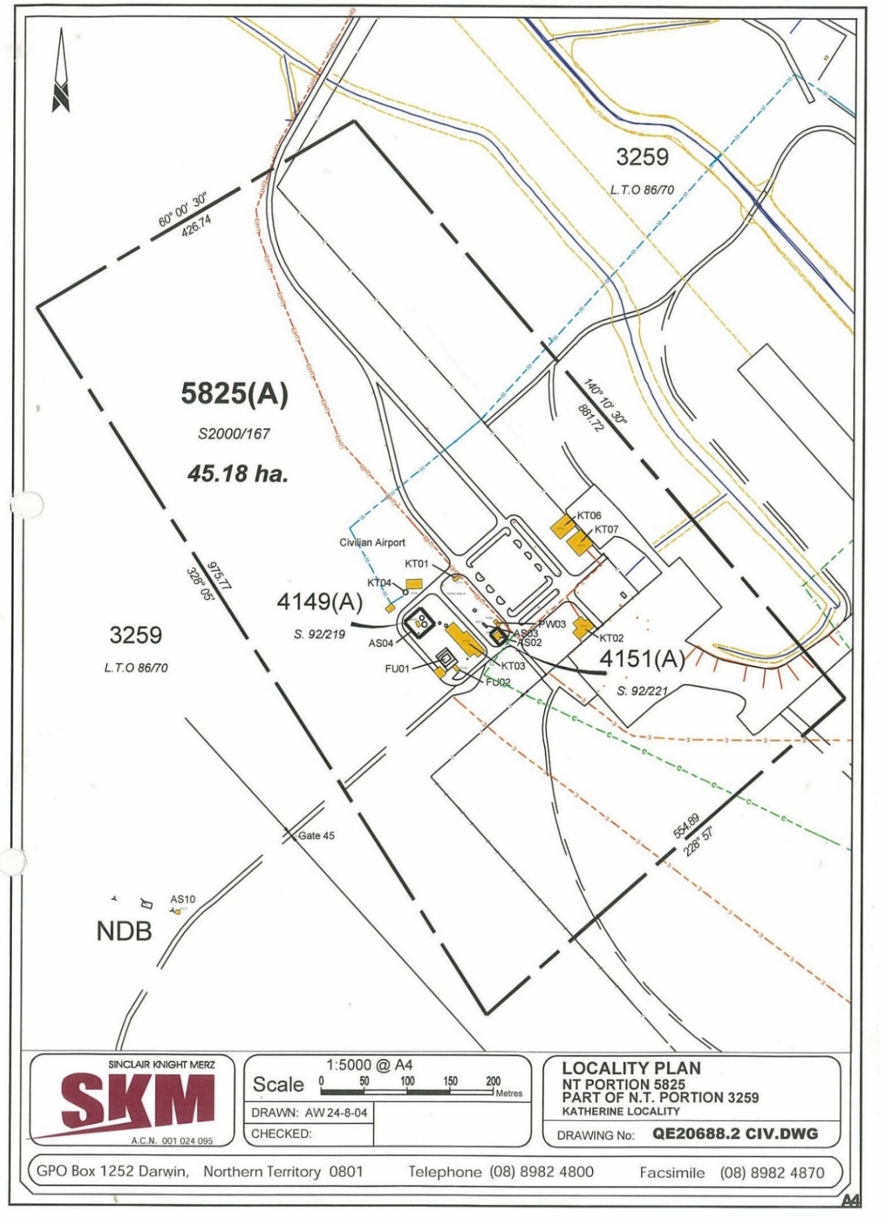

- KATHERINE CIVIL AIRPORT AERIAL VIEW

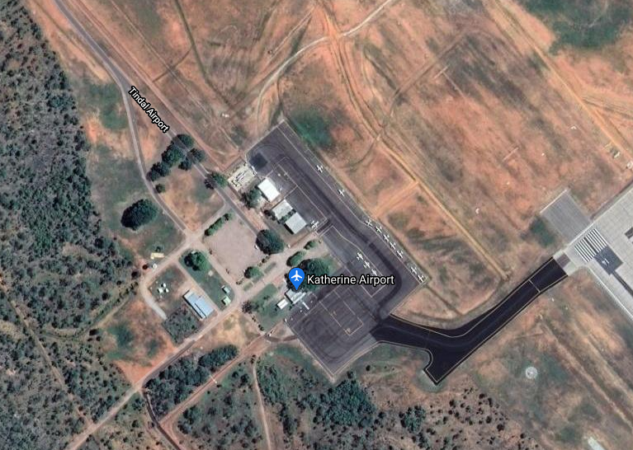

- KATHERINCE CIVIL AIRPORT TERMINAL BUILDING LAYOUT

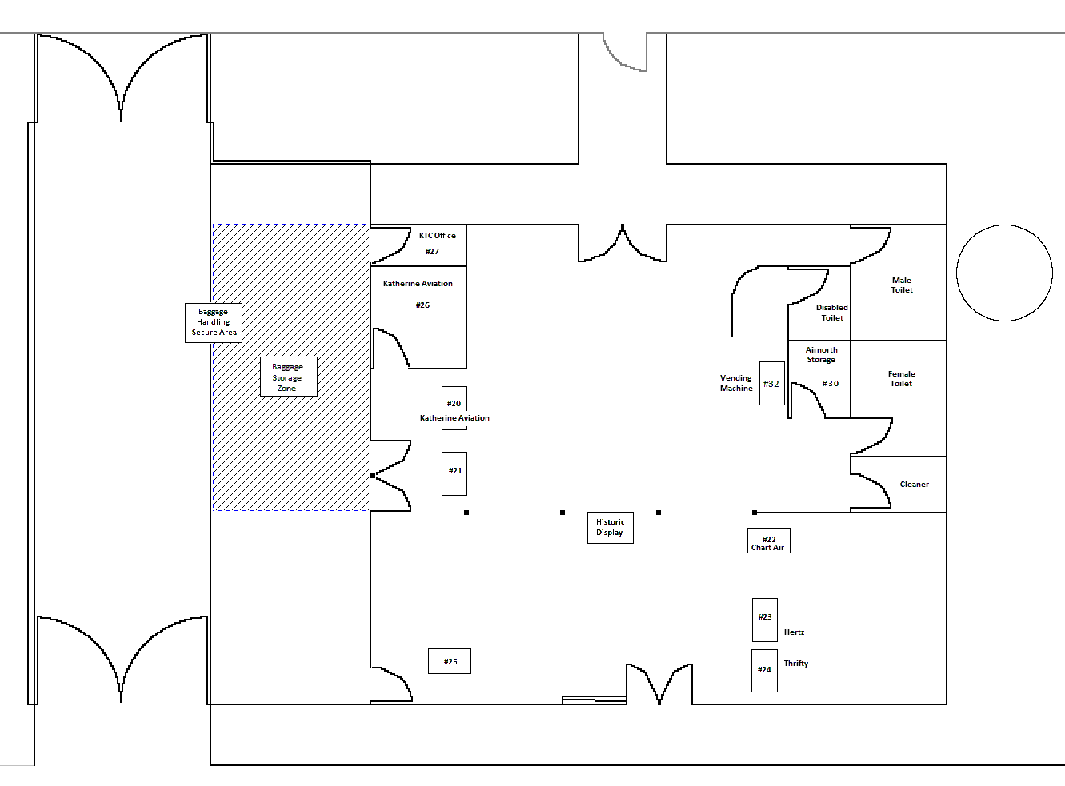

- KATHERINE CIVIL AIRPORT ANCILLARY BUILDING AND WORKSHOP LAYOUT

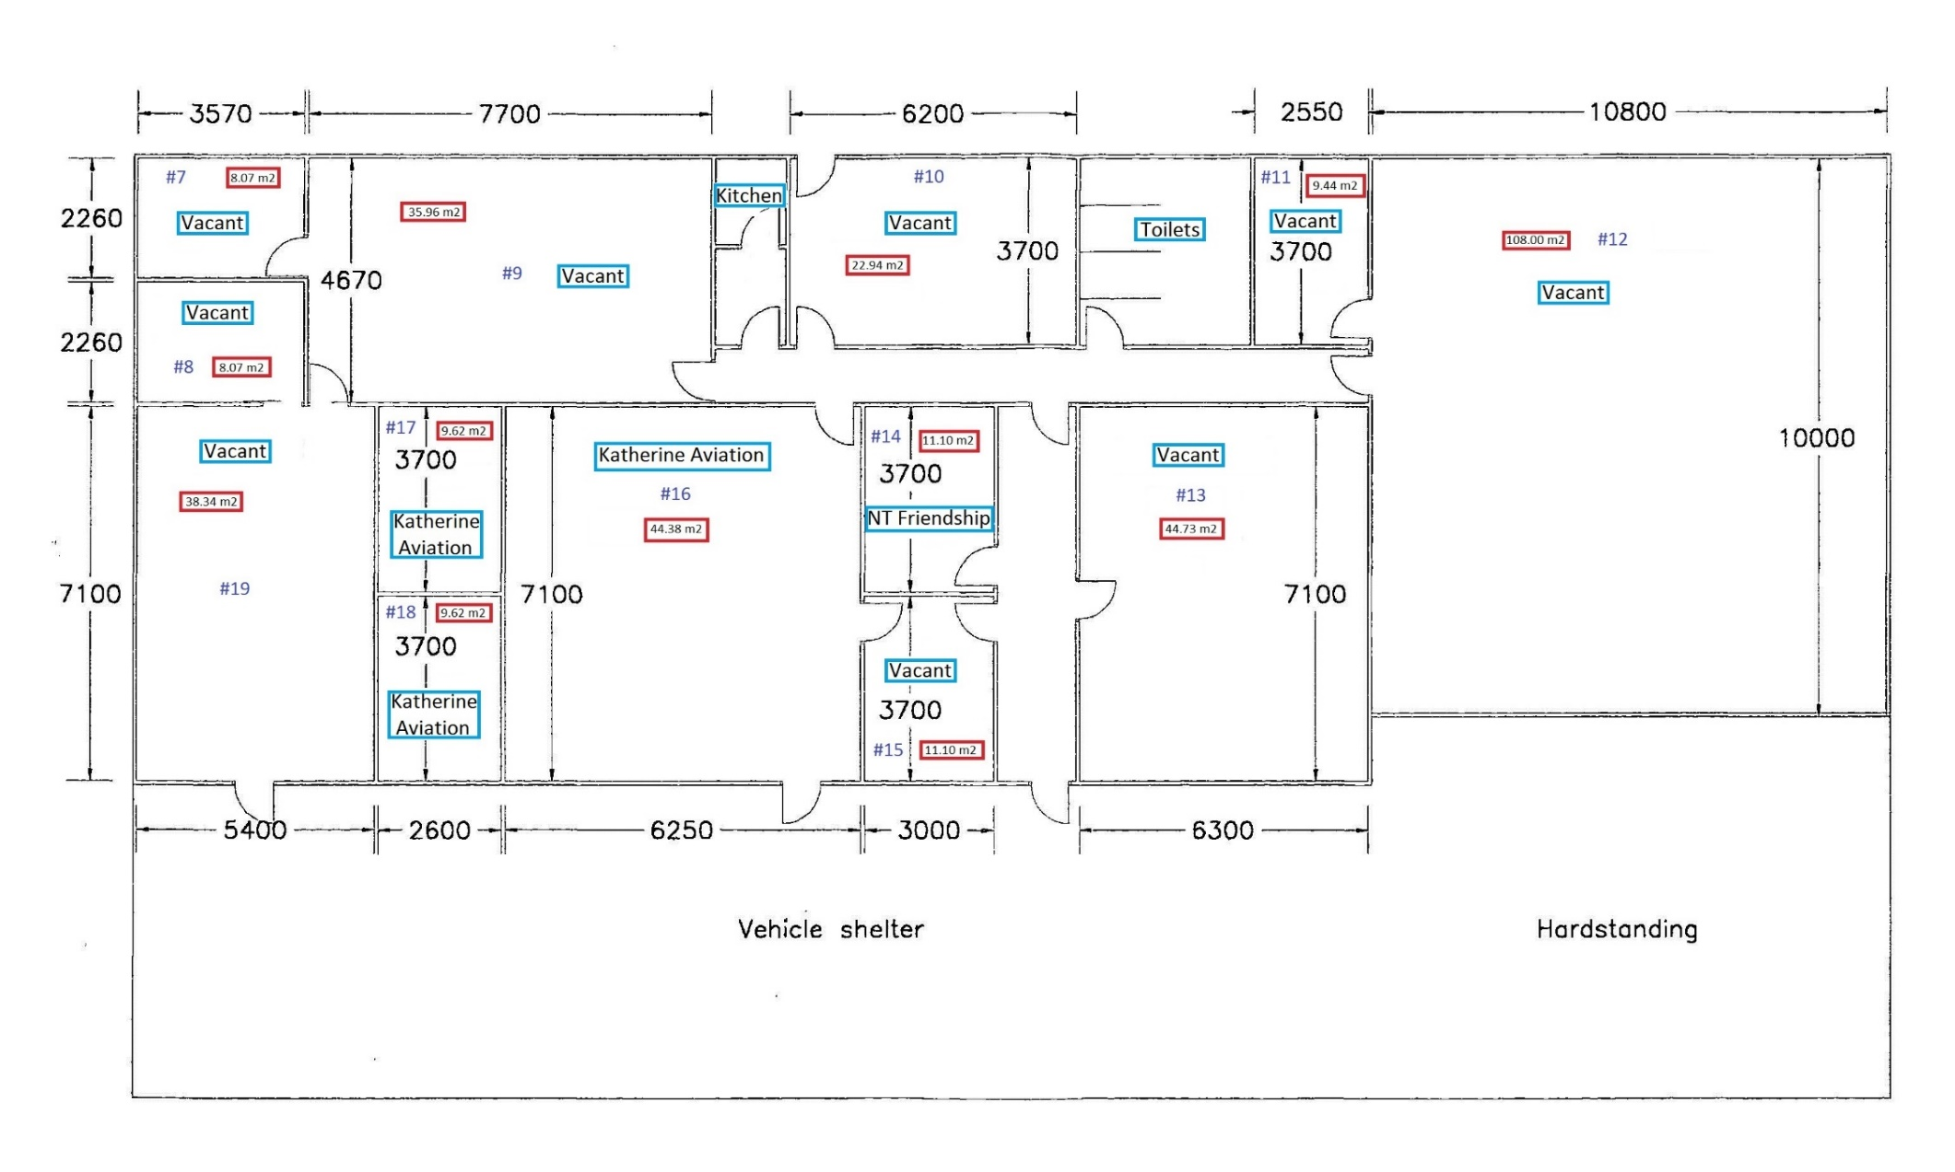

- SUPPLEMENTARY INFORMATION

- Financial Summary (excluding GST. Figures are approximate)

2020/2021 | Description | $
Income | Landing Fees | 328,982
 | Rents and other revenue | 132,887
 | Total Revenue | 461,869
Expenditure | Operating Lease | 4,000
 | Electricity | 23,813
 | Employee Costs | 30,166
 | Repairs & Maintenance | 19,357
 | Cleaning | 13,937
 | Administration & Insurance expenses | 40,373
 | ARO & Security expenses | 45,340
 | Vehicle (internal plant hire) | 7,070
 | Total Expenditure | 184,056
2019/2020 | Description | $
Income | Landing Fees | 370,000
 | Rents and other revenue | 107,000
 | Total Revenue | 477,000
Expenditure | Operating Lease | 14,000
 | Electricity | 21,000
 | Repairs & Maintenance | 39,000
 | Cleaning | 14,000
 | Administration & Insurance expenses | 43,500
 | ARO & Security expenses | 28,000
 | Total Expenditure | 159,500
- NOTES

Aircraft landing and parking fees
- All landing fees are processed by Avdata via radio monitoring.
- All parking is recorded by AROs with incidental parking processed by Avdata and permanent parking processed by KTC (occupational agreement).
- Details of incidental and permanent parking, and fees and charges are available on Council’s website and included in:
*Appendix 1 Katherine Civil Airport General User Conditions
*Appendix 2 Katherine Town Council’s Schedule of Fees and Charges 2021/2022

Aeronautical charges e.g. per PAX or per tonne
- KTC do not record or charge according to PAX.
All tenancy, parking and service charges are specified in KTC’s Schedule of Fees and Charges, updated annually and available on KTC website. *Appendix 2 Katherine Town Council’s Schedule of Fees and Charges 2021/2022
- From early 2020, KTC no longer provided any airside services.

Katherine Airport AAA industry membership
- Membership not current.

RPT schedule(s)
- Only one RPT Service, three times per week, max 30 PAX - operated by Airnorth - subsidised by NTG.
- There are no arrangements for passenger lists or flight details to be provided to KTC.

Operating deed between Council and the RPT provider(s)
- Only the one regular RPT service - Airnorth’s Central Run (Darwin - Katherine - T. Creek - A. Springs) - three times per week, max 30 PAX - subsidised by NTG.
- There are no arrangements for passenger lists or flight details to be provided to KTC. Airnorth access to facilities (airside storage, baggage handling, etc) is detailed in their lease.

Building condition reports
  - Reports were completed when the RAAF lease was signed in 2014/15.
  - Past groundside inspections have been:
    - Building Compliance Report for Warehouse in 2019. *Appendix 3 - Warehouse - Building Compliance Report
    - Inspection of Terminal and Warehouse for asbestos. *Appendix 4 - Katherine Civil Airport Asbestos Register
    - Inspection of Hangar Precinct for underground utilities.
    - Inspection of grounds for irrigation elements.

Buildings - cleaning, repairs and maintenance
- Currently cleaning contracts are in place only for the Terminal and general waste collection.
- Warehouse and Hangars has no arrangements. Each tenant is required to maintain cleanliness and order.

Most recent airport inspection / audit report(s), conducted by CASA or in house
  - No CASA inspections have occurred.
  - Past airside inspections have been:
    - Inspection of flushing & blistering of RPT & GA pavement.
    - Inspection of RPT pavement to determine PCN.
*Appendix 5 - Tindal Aerodrome - Apron Pavement Assessment

Apron / Taxiway pavement condition reports (incl most recent Annual Technical Inspection report)
- No Annual Technical Inspection reports have been undertaken.
- Although Taxiway echo is within the ‘lease area’ and subject to daily ARO inspection, it is maintained by RAAF.

Aerodrome Reporting Officer duties
- ARO duties only extend to the civil aprons and Taxiway Echo. No inspections of runway or other taxiways are undertaken (or permitted). RAAF undertake inspections and this may be several times a day, depending on their own flying requirements.
- KTC undertake daily ARO inspections of the KCA during weekdays, and engage a contractor for weekends, holidays and staff absences. *Appendix 6 - KCA Serviceability Inspection Check List
- No Technical Inspections or security assessments or other related inspections are undertaken.

Current Aerodrome Manual and Aerodrome Emergency Plan
- No Aerodrome Manual or Aerodrome Emergency Plan - preparation of each (and other related documents) forms part of the works being tendered.
- KTC have a General Users Conditions that apply to all KCA users equally, and Tenancy Schedules for each tenant individually.
*Appendix 1 Katherine Civil Airport General User Conditions
*Appendix 7 - KCA Tenancy Schedule - Template

Insurance mandates
- All tenants are asked to include appropriate insurance details on their lease agreement.
- All air service operators are required to have insurance for aircraft and vehicles going airside.
- KTC has insurance for its own vehicles approved to go airside.

Typical Maintenance Operations
- Airside
- Minor maintenance and repair of all apron surfaces
- Line markings and cones/markers
- Signage
- Light tower fittings and poles
- Clean up of oil/fuel spills
- Maintenance of Spill Kits
- Ensure operation of access gates (reporting and liaising with RAAF and contractors)
- Groundside
- Roads and Carparks
- Minor maintenance and repair of all bitumen surfaces
- Line markings
- Lighting
- Signage
- Landscaping
- Cleanliness and general presentation
- Watering and fertilising grassed areas to maintain green spaces
- Controlling pests and insects to ensure no damage to vegetation or inconvenience to users
- Ensuring ongoing weeding and all garden beds are mulched
- Removing all garden waste including clippings and tree branches
- The provision and maintenance of equipment, hoses, irrigation and sprinklers necessary to maintain the lawns and planted areas
- The provision and maintenance of the equipment needed to maintain the lawns and vegetated areas including mowers, edges, and whipper snippers
- Repair of seating, bins, and other outdoor furniture
- Buildings
- Cleaning, repair and maintenance of interior and exterior of buildings to an acceptable standard that ensures both functionality for their purpose and maintains and attractive and welcoming image of Katherine
- Minor repairs and replacements of fixtures and fittings (lights, electrics plumbing air-conditioning, tiles/paving, doors and locks, etc)
- Ensuring the airport facilities are in a serviceable condition
- Maintaining a high standard of hygiene and presentation
- Maintenance and repair of all security cameras, alarms and lighting
- All telecommunication service fees and charges associated with management and operations
- Scheduled maintenance, repairs and component replacements for all buildings and other facilities
- Minor painting to protect and enhance buildings
- On-going KTC responsibilities
- Waste collection
- Major tree removal/treatments
- Major building renovation

Capital Asset Management
- Replacement or upgrade of whole electrical distribution boards and systems
- Major building refurbishments
- Replacement/maintenance of structural building components, roofing and concrete floors
- Renewal/upgrade of airside pavement
- Construction of new facilities to meet future demand for greater passenger numbers (e.g., security screening) or for increased freight

*References (Addenda)
*Appendix 1 Katherine Civil Airport General User Conditions
*Appendix 2 Katherine Town Council’s Schedule of Fees and Charges 2021/2022
*Appendix 3 - Warehouse - Building Compliance Report
*Appendix 4 - Katherine Civil Airport Asbestos Register
*Appendix 5 - Tindal Aerodrome - Apron Pavement Assessment
*Appendix 6 - KCA Serviceability Inspection Check List
*Appendix 7 - KCA Tenancy Schedule - Template

