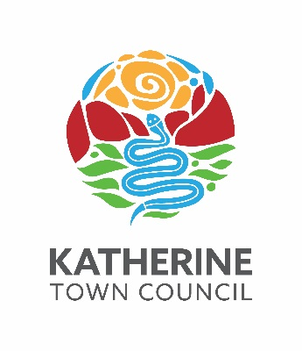

Transmittal

for

Katherine Town Council

ABN 47 836 889 865

regarding

Tender 22/06

“MANAGEMENT SERVICES
FOR
KATHERINE CIVIL AIRPORT”

CLOSING

2:00pm, TUESDAY 16 November 2021

TENDER BOX KATHERINE CIVIC CENTRE, STUART HIGHWAY, KATHERINE

Tender 22/06

“MANAGEMENT SERVICES FOR KATHERINE CIVIL AIRPORT”

Contract Documentation | Pages
T22/06 - Scope of Works - Management Services for Katherine Civil Airport | 1 - 31
T22/06 - Response Schedules - Management Services for Katherine Civil Airport | 1 - 12
T22/06 - Conditions of Contract v5.4 - Management Services for Katherine Civil Airport | 1 - 28
Appendix 1 - Katherine Civil Airport General User Conditions | 1 - 16
Appendix 2 - Katherine Town Council Fees & Charges 2021-2022 | 1 - 41
Appendix 3 - Warehouse - Building Compliance Report | 1 - 8
Appendix 4 - Katherine Civil Airport Asbestos Register | 1 - 1
Appendix 5 - Tindal Aerodrome - Apron Pavement Assessment | 1 - 71
Appendix 6 - Serviceability Inspection Check List | 1 - 2
Appendix 7 - KCA Tenancy Schedule - Template | 1 - 15

ENQUIRIES:

Technical nature regarding the work required should be referred to:
- Director Infrastructure & Environment 08 8972 5500 or records@ktc.nt.gov.au

Tendering procedures or the like should be referred to:
- Director Corporate Services 08 8972 5500 or records@ktc.nt.gov.au

Tendering documentation requests to:
- Infrastructure & Environment Administration Officer 08 8972 5500 or records@ktc.nt.gov.au

