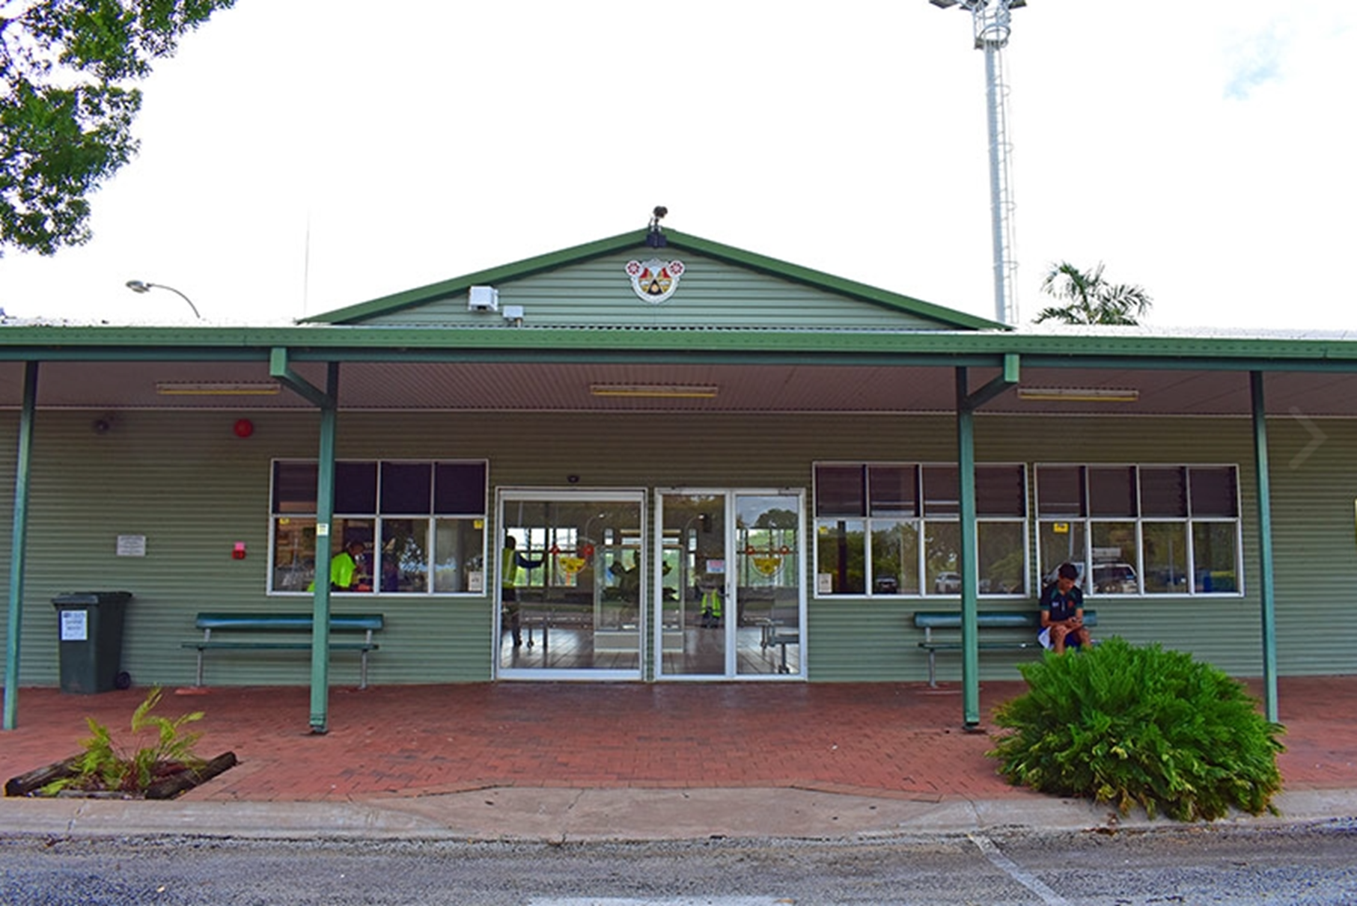

KATHERINE TOWN COUNCIL
KATHERINE CIVIL AIRPORT
MANAGEMENT SERVICES AGREEMENT
Expression of Interest

Contents

Message from the Mayor... 4
1. Introduction 5
2. Process 6
3. The Opportunity – Katherine Civil Airport Operations 7
4. Performance Objectives 9
5. Operational Requirements 11
6. Information Required for EOI 14
7. Terms and Conditions 16
Attachments 18

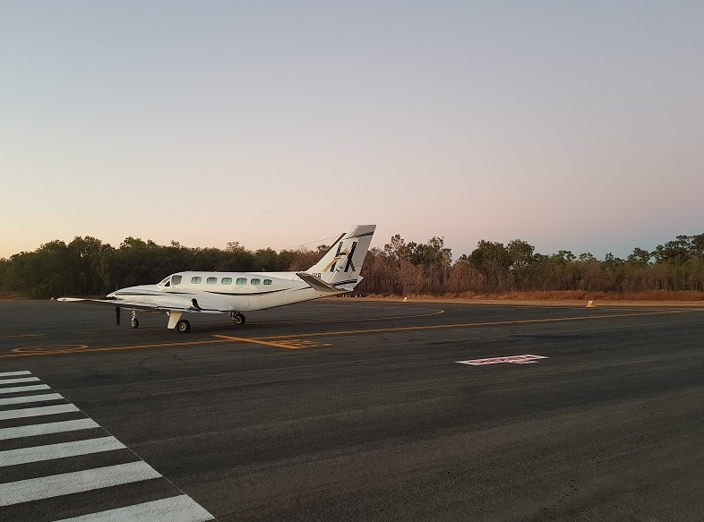

Message from the Mayor...

The Katherine Civil Airport Tindal (KCA) is located approximately 15 kms south of Katherine, along the Stuart Highway.
The Katherine Town Council established a working arrangement with RAAF Base Tindal in the early 1990s for the joint usage of the airstrip and associated facilities.
Katherine Town Council is committed to the professional management of the airport. This key facility supports the town and surrounding communities, through logistics, tourism, industry and counter-disaster and medical emergency response.
An opportunity is available to an appropriately qualified airport management company to operate the Airport on behalf of Council.
As detailed further in this document, significant infrastructure and existing and expanding business arrangements are included in this opportunity.
Katherine Town Council invites all interested parties to submit their vision for the Katherine Civil Airport as part of the Expression of Interest process.

Elisabeth Clark
Mayor of Katherine

Introduction

  - Invitations for Expression of Interest (EOI) – Professional Airport Management Services

Katherine Town Council (Council) invites Expressions of Interest to enter a professional services Agreement for the operational management of the Katherine Civil Airport (KCA) for a period of six (6) years with two further options of ten (10) years each subject to satisfactory performance.

Council has an objective to secure sustainable and properly qualified management of the Katherine Civil Airport that is cost neutral for Council and delivers a high standard of service to clients and the community and builds strong relationships with all stakeholders.

  - Scope of the Airport Management Service Provider (‘Operator’)

Under the proposed operational Agreement structure, the Operator will be required to provide suitably qualified and experienced Airport Management personnel and systems to operate and maintain KCA and its associated facilities in accordance with high safety standards, operational excellence, industry best practice and quality assurance protocols for the period of the agreement.

The Operator will be responsible for the overall operations of the KCA and incur all costs associated with the operations, including all statutory fees, charges, and outgoings.

The Operator will be responsible for ongoing routine maintenance of the KCA facilities and related fixtures and fittings over the term of the
agreement.

  - Katherine Civil Airport

Katherine Town Council leases the Civil Airport site of RAAF Base Tindal from the Commonwealth of Australia (Department of Defence). The Lease incorporates a Licenced area over Runway 14/32, Taxiway Alpha and Taxiway Echo. The Head Lease Provisions including the Leased Premises and Council obligations are described in 3.1 of this document.

Katherine Town Council receives income from tenants, landing and parking fees, and other revenue streams arising from the airport operations within the Leased Premises. Under the proposed operational Agreement structure, the Operator will receive a percentage of this gross revenue, paid monthly in arrears, as the Contract payment for the provision of the Airport Management Services. This percentage will be proposed by the Tenderer through the EOI process.

Process

  - Operational Management Overview

The Katherine Civil Airport currently has no on-site management and daily operations are managed remotely from the Katherine Town Council main office at the Civic Centre, Stuart Highway, Katherine.

Council is seeking a suitable proposal from an appropriately resourced and experienced operator to enter into a Professional Management Services Agreement for the operations of the Katherine Civil Airport.

The commencement date for the Agreement will be based on the selection of the preferred operator, submission of required documentation and the receipt by Council of written approval by the Department of Defence as required by the Head Lease.

Council expects to determine the outcome of the Expression of Interest (EOI) process and inform respondents no later than 25 June 2021.

  - Briefings

Individual briefings to discuss further the management opportunity are optional and prospective operators must contact Council’s Director Infrastructure and Environment, Mr Brendan Pearce (08 8972 5500) to arrange. Alternately send an email to records@ktc.nt.gov.au Attention to Brendan Pearce.

  - Questions

Questions regarding any element of the Expression of Interest process will be accepted up until three (3) business days prior to the closing date for the EOI. All questions are to be addressed in writing to the Director Infrastructure and Environment, Mr Brendan Pearce.

The Opportunity – Katherine Civil Airport Operations

  - Head Lease Provisions

- The Commonwealth of Australia, through the Department of Defence (DoD), owns all of the land known as ‘RAAF Base Tindal’ which is comprised in NT Portion 3259 on Deposited Plan 86/070 being the land comprised in Certificate of Title Volume 753 Folio 307, the Leased Premises being the portion identified as Portion 5825(A) on survey plan S2000/167.

- RAAF Base Tindal is a Defence aerodrome controlled by DoD as referred to in section 20 of the Civil Aviation Act 1988 (Cth).

- DoD has agreed that Council may use RAAF Base Tindal on the terms and conditions set out in the Lease and the Operating Deed.

- The Council has agreed that:
  - subject to the Lease and Operating Deed it will comply with relevant legislation as if it were the operator of a certified aerodrome under the Civil Aviation Safety Regulations 1998 (Cth); and

  - it will comply with any conditions specified by the Civil Aviation Safety Authority pursuant to section 20 of the Civil Aviation Act 1998 (Cth).

- RAAF Base Tindal comprises three (3) areas being:

  - The Military Area;

  - The Civil Airport Site; and

  - The Licensed Area.

- DoD uses the Military Area as a RAAF base.

- DoD has granted a lease to the Council that expires on 30 September 2027 and Council accepts a lease of the Civil Airport Site on the terms of this lease. Subject to the terms of clause 45 of the lease, two further option periods of ten (10) years each, the first commencing on the day after the expiry of the initial Term and the second commencing on the day after the expiry of the first further term, are available.

- The Licensed Area is used by the parties to this lease and by third parties.

- Operations by civil aircraft traffic are controlled by the requirements and limitations of the Operating Deed relating to the Licensed Area at RAAF Base Tindal.

  - The Katherine Civil Airport comprises of the following Buildings, Facilities, and Infrastructure Assets

Airport Passenger Facility:
- Check-in kiosks with baggage scales are provided.
- There is a vending machine inside the terminal that returns a per annum site rental.
- Toilets are in good condition. A new septic system is in place and water is potable.
- Airside is accessed by swipe-card through security gates.
- An appraisal has confirmed that asbestos is not present within the terminal building.

Hangars
- There are two established hangars and one under construction.
- There are current tenants in these hangars who also have assigned GA parking.

Warehouse/ Offices
- This is a large building with multiple offices and storage space.
- Businesses currently lease rooms and storage areas.
- The walls, ceilings and floors are in very good condition with no damage. Asbestos has been confirmed in some building components and an asbestos report is available.

Aprons
- The RPT apron is in fair to poor condition.
- The GA apron is in fair condition.
- The line-marking is faded in parts.

Taxiway Echo
- The taxiway is in good condition.
- A pipe culvert runs beneath the taxiway, is not rated and consequently the use is generally limited to small GA aircraft of less than 5,700kg MTOW.

Fuel Facility
- The fuel facility is operated by local company on behalf of VIVA and BP.
- AVGAS is uplifted from a card-swipe bowser and Jet Al provided from a 16,000-litre truck.
- The council has no responsibility regarding refuelling operations.

Tenderers are encouraged to contact Katherine Town Council to arrange access to inspect the facilities prior to submitting their proposal.
Appointments can be arranged by contacting the Operations Manager on (08) 8972 5500 or email records@ktc.nt.gov.au

Performance Objectives

  - General
The KCA provides a key service to the community and region. Operation of the site need to provide both tangible and intangible beneficial community outcomes that Council consider important to enhance the KCA as part of the Agreement. The on-site presence of the Operator is central to optimising the value of the KCA to the community and minimising risk to Council with the successful Operator demonstrating alignment with Council’s goals:
- To enhance the precinct as user friendly, safe, and inviting space;
- To maximise the economic, social, and cultural benefits to the town and wider community;
- To develop a business model that enables commercial viability for the Operator and a cost neutral or enhanced position for the Council; and,
- To transfer airport maintenance, compliance, and replacement responsibilities/liabilities to the Operator. These objectives should be addressed in all EOI responses.

  - Community engagement, business opportunities and strategic planning
    - Preparation of multiple funding applications on behalf of the Katherine Town Council, including collating letters of support, quotations, and justifications
    - Facilitate and manage tenancies and other commercial arrangements for use of airport facilities and grounds. Ensure customer service delivery is of the highest standard. Optimise community benefits, usage, and revenue to offer the ability to grow the business opportunities
    - Encourage Indigenous participation and provide local training programs and pathways for local workers to become Aerodrome Reporting Officers and Work Safety Officers and ground operations staff
    - Facilitate public art installations and displays by local artists, historical society, and Chamber of Commerce to promote information about local indigenous culture, regional history, tourism, recreation, entertainment, and business opportunities
    - Engage with local indigenous artists to make visible ‘Welcome to Country’ statement
    - Conduct feasibility study of regional air routes and potential to increase accessibility of commercial and domestic flights for residents and businesses in Katherine and surrounding communities
    - Maintaining membership to the Airports Association of Australia ("AAA") to enable representation and inclusion to the industry’s peak body of representation on a federal level
    - Actively participate in stakeholder meetings

  - Aerodrome and facility management
The Operator will provide on-site management and assume responsibility for the ongoing maintenance, compliance, and operational matters.

  - Maintenance
- Develop a maintenance plan for both airside and landside facilities. The initial plan will have a basic maintenance regime that will be tailored to improve the overall condition of the KCA.
- As part of the daily inspections, the Airport Manager will ensure that all airport infrastructure, taxiways & apron, work areas, common use areas, equipment and vehicles are monitored for serviceability and presentability. Taxiway and apron lighting will be checked, and globes will be immediately replaced.
- Ensure customers are well looked after and the facilities are kept and maintained in safe and good working order.

  - Aerodrome Regulations and Operations
- Implement advanced management and administrative systems to govern the operation of the airport
- As a certified aerodrome under CASR 139 and MOS 139, an aerodrome must be maintained and operated in accordance with the regulations and the approved Aerodrome Manual. Write an Aerodrome Manual specifically for the existing operation of the airport and define the aerodrome's procedure and processes.
- Manage all facility requirements under the Head Lease arrangements between the Operator, Katherine Town Council, Defence/RAAF, and the facility lessees
- In line with the Operating Deed, ensure the operation is in accordance with this governing document and provide suitably experienced and qualified staff to fulfill duties in line with the operational scope of work outlined in the document.

  - Quality Assurance
- Provide safe, cost effective services consistent with the Katherine Town Council ’s standards and requirements by the implementation of a Quality Management System, in accordance with the requirements of ISO 9002-1994 Quality Systems Model for Quality Assurance in Production, Installation and Servicing.

  - Client Interface
- The onsite Aerodrome Manager will be the primary contact to the Aerodrome customers and lessees, RAAF and Katherine Town Council and will interface on all the above matters through provision of written reports and attendance to meetings on a regular basis as agreed with and by the Operating Deed.

  - Industry Association
- The Katherine Aerodrome Manager will commit to at least one Northern Territory Australian Airport Association conference per year.

5. Operational Requirements

5.1. Project Plan
On commencement of the term of the Agreement, the Operator will undertake the following in consultation and handover with the Katherine Town Council as a project plan with key milestones and key performance indicators.
- Meet and introduce the Operator to all applicable stakeholders to present the vision for the KCA.
- Write and Implement the Aerodrome Manual with applicable stakeholder engagement.
- Write and Implement a Safety Management System with applicable stakeholder engagement.
- Implement the Drug and Alcohol Management Plan with applicable stakeholder engagement.
- Develop and execute a remediation plan for the Apron areas.
- Develop and schedule a dedicated maintenance plan for areas of responsibilities under the KCA contract.
- Write aerodrome specific policies with applicable stakeholder engagement for areas of responsibilities under the KCA contract.
- Develop and compile an asset register for areas of responsibilities under the KCA contract.
- Format reports to be submitted to Katherine Town Council and RAAF at intervals agreed to by applicable stakeholders.
- Handover from Katherine Town Council to Operator of operational responsibility with applicable stakeholder engagement for areas of responsibilities under the KCA contract.
- Apply for funding through government and private avenues for identified priority and longer­ term needs and improvements.
- Provide timelines and strategy to achieve project Plan

  - Operational Management
The onsite management will undertake all administrative, compliance and regulatory tasks including:
- Record Keeping/ Training Records.
- Provision of required reports to Katherine Town Council and RAAF documentation updates.
- CASA or RAAF inspections and surveillance audits, action plans and close outs DITRDLG requirements/ Audit Actions.
- DAMP Responsibilities (part 99 of MOS 139).
- Emergency Committee Management (in alignment with RAAF).
- Emergency Exercise Planning (in alignment with RAAF).
- Annual Technical Inspection Audit action.
- Fuel Company Requirements (Align with current provider).
- Recording of all aircraft movements and aircraft type as per the Operating Deed.
- Quality Assurance and Quality Control plan.
- Manage all RPT movements as per the Operating Deed.

During the terms of the Agreement, the Operator will be responsible for:
- All costs associated with the operation of the airport.
- All statutory fees, charges, and outgoings, including water, power, sewer etc.
- Agreed contribution to capital renewals and upgrades during the Agreement as applicable.
- Routine maintenance of the airport facilities and infrastructure as agreed with Council.
- Ensuring use of the Airport is always compliant with the terms of the Agreement and CASA regulations.
- At the end of the Agreement the Operator will be responsible for making good, including reinstatement of services, fittings, fixtures, and modifications carried out during the Agreement, except for the agreed capital upgrades if applicable.

  - Airport personnel and routine tasks
    - Accountable manager/s.
    - Aerodrome Manager available on call 24/7/365 with applicable annual leave, suitably qualified and experienced and tasked with the operation and maintenance of the KCA and associated facilities.
    - Aerodrome reporting officer/s.
    - Work safety officer/s.
    - Ground handling and security personnel as required.
    - Civil and electrical works for repairs, maintenance, and installations.
    - Compliance and document control to meet Part 139 MOS Standards.
    - Technical, lighting, and electrical inspections.
    - Aerodrome surveys and assessments.
    - Aerodrome equipment supply.
    - Taxiway and apron sweeping and rolling.
    - Taxiway and apron line marking.

  - Ground’s maintenance including
    - Sweeping taxiway and apron, carparks, and roads.
    - Grass cutting/slashing.
    - Trimming trees.
    - Maintaining gardens.
    - Picking up rubbish.
    - Fencing.

  - Building maintenance including
    - Cleaning.
    - Minor repairs and painting.
    - Test and tag and routine inspections.

  - Regulatory compliance - providing documentation for regulatory compliance including:
    - Aerodrome certification, maintaining current documents.
    - Aerodrome Manuals.
    - Drug and Alcohol Management Plans (DAMP).
    - Safety Management Systems (SMS).
    - Risk Management Plans (RMP).
    - Emergency Response Plans (ERP).
    - Emergency Preparedness Plans (EPP).
    - Change Management Plans (CMP).
    - Wildlife Hazard Management Plans (WHMP) CASR 175.
    - Aeronautical Information Products (AIP).
    - Method of Works Plan (MOWP).
    - Transport Security Plans (TSP).
    - Aviation Security Identification Cards (ASIC) issuing body.

  - Investment/Financial Agreement
Council is seeking an Operator who is prepared to invest in the KCA and realise its potential over the long-term, and who will:
- invest time, financial and other resources into the development and implementation of compliance related items to ensure the KCA meets the standards and is correctly operated and compliant with Civil Aerodrome Aviation Standards as per the regulatory requirements of Part 139 MOS.
- make provisions for future growth to support Katherine, its people, and its businesses.
- exhaust all available funding avenues to support the KCA and will also lobby government and private avenues to be able to assist with the overall cost and ongoing maintenance of the KCA to ensure it remains financially viable to continue to support the Katherine community.
- engage in discussions with the Katherine Town Council around what investment strategies would bring value to the KCA and discuss budget forecasting for the facility.
- support the operation through the KCA revenue streams from lease payments, landing fees and other incomes generated from commercial airport operations.
- present council with regular reports detailing the operations and status of the KCA outlining the health of the KCA with compliance, financial, growth opportunities, investment availability (grants etc) and customer feedback.

Other Uses
Council is open to the Airport being utilised for complementary purposes aligned with its objectives. However, uses that are inconsistent with Council’s objectives or those that do not complement or support preferred community outcomes will not be supported. EOI respondents are to include all proposed alternative uses as part of their EOI submission.

Consideration of alternative uses will also be subject to any other permissions or regulatory approvals for the site.

Agreement Term
Council is prepared to offer an Agreement term of six (6) years. Subject to satisfactorily meeting the requirements of the Head lease, two further option periods of ten (10) years each, the first commencing on the day after the expiry of the initial Term and the second commencing on the day after the expiry of the first further term, are available. This is to enable the Operator to maximise returns and deliver benefits in line with Council’s objectives noting the significant long-term strategic planning and asset renewal program required to sustain this asset and associated enterprises.

Agreement Boundary
The proposed Agreement boundary is shown in Attachment One.

Approvals
The Operator will be responsible for obtaining and all approvals required in order undertake operations.

Information Required for EOI

To enable Council to assess EOI responses received, each EOI respondent is required to complete the attached Katherine Civil Airport Management Agreement – Expression of Interest Response Schedule.
The Expression of Interest Response Schedule sets out the form and content required to be submitted in each EOI response. Respondents are strongly advised to observe the content and guidelines included in the response schedule.
Attachments with additional information may be included with EOI responses.

Evaluation Criteria
Council will use the following criteria to evaluate EOI responses:
  - Experience and track record in similar operation management;
  - Financial capability and capacity;
  - Organisational capability and capacity;
  - KCA vision including social, cultural, and recreational benefits to the town and/or the region; and
  - Sustainability and financial arrangements.

Detail of Evaluation Criteria
Provided below, are further details of each evaluation criterion that will be used by Council in its evaluation of EOI responses.

Experience and Track record in similar airport operations management
Respondents are to clearly outline their track record and experience in managing and operating operations or related of comparable size and nature. Specifically, respondents should provide examples of operations and document notable achievements and successes in the last five years.

Financial Capability and Capacity
Respondents should provide evidence of their financial capability and capacity to meet the obligations of the Agreement term and their ability to support the daily operations and maintenance of the site as required under the Agreement.

Organisational Capability and Capacity
Respondents should provide evidence of their organisational capability and capacity to meet the obligations of the Agreement term and their ability to manage the daily operations and maintenance of the site to a high standard as required under the Agreement.

Vision and Local Benefit
Respondents should explain their vision for the Katherine Civil Airport and provide details of how and the extent to which the vision aligns with Katherine Town Council objectives. Respondents should clarify any proposed variations to Council’s preferences.

Sustainability and Financial Arrangements
In accordance with Katherine Town Council’s objectives as expressed in the EOI documentation, 5.7 Investment/Financial Agreement, respondents should specify the management model and financial arrangement that enables commercial viability of the Airport Management Services Provider (‘Operator’), and a cost neutral position for Katherine Town Council, in relation to the Katherine Civil Airport.

Selection Process
Council will review and assess each EOI response in accordance with the following process:
Step 1: Initial review of each EOI response to confirm that all required components of the submission are present and, in a form, capable of evaluation.
Step 2: (For each EOI response which is confirmed as including all required components in a form capable of evaluation) Detail assessment and review of specific content of the EOI responses against each of the evaluation criteria to rank EOI responses. (NOTE: Katherine Town Council may seek any necessary clarification of any elements of a respondents EOI to complete the detailed evaluation).
Step 3: Katherine Town Council to enter in direct negotiations with the preferred respondent, confirming Agreement provisions including term and financial contribution payable.
Step 4: Confirmation of Agreement award by Katherine Town Council Resolution.

Evaluation Process
- Council will not be bound to engage any respondent or review any EOI response that does not conform to the requirements set out in this EOI.
- The respondents acknowledge that Council is not bound to accept any EOI response submitted in response to this EOI and may terminate the process at any time.
- The submission of an EOI response does not give rise to any contract governing, or in any way concerning, the EOI process, or any aspect of the EOI process. Council expressly disclaims any intention to enter into such a contract.

Terms and Conditions

  - Lodgement Details
The respondent must provide Council with one copy in a sealed envelope marked “Confidential – Katherine Civil Airport – Expression of Interest” to the Tender Box at:

Katherine Town Council Civic Centre 24 Stuart Highway
KATHERINE NT 0850

Or

One electronic copy of its EOI response online via records@ktc.nt.gov.au

Or

Via prepaid post to PO Box 1071, Katherine NT 0851

Or

Submit your response via Tenderlink online portal

  - Closing Date and Time
The closing time for submission of EOI’s is 2.00pm (Central Standard Time) on Monday 31 May 2021. Katherine Town Council will not consider late EOI’s.

  - Costs to be borne by Respondents
Katherine Town Council or any other agency or their respective officers will not be responsible for any costs or expenses incurred by any respondent in preparing or lodging an EOI response or in complying with the EOI process.

  - Confidentially and Propriety Information
Subject to the terms of this EOI, Council will hold all EOI responses in confidence in so far as the law permits. The EOI responses will become Council’s property. Without limitation, each respondent authorises Katherine Town Council to use and reproduce the whole or any portion of the respondent’s EOI response for the purposes of evaluation.
Any personal information collected as part of the EOI process will be handled in accordance with the Privacy Act.

  - Canvasing
The respondent, its employees, and consultants, must not approach, or request any other person to approach, any Elected Member, member of Katherine Town Council’s staff or consultant engaged by Council:
- to solicit support for its EOI response; or
- otherwise seek to influence the outcome of this invitation for EOI.
The respondent will direct all communications during this EOI process to the location provided in section 6.3.
If a respondent breaches this clause Katherine Town Council may, in its sole discretion, disqualify the respondent from participating in this EOI process.

  - Conflict of Interest
Respondents must declare to Katherine Town Council any direct or indirect conflict of interest in respect of the Council or this EOI process.

  - Public Statements
A respondent must not make any public statement in relation to this EOI process and must refer all enquiries from the media to Katherien Town Council.

  - Change in Circumstance
Each respondent must inform Katherine Town Council promptly in writing of any material change to any of the information contained in the respondents EOI response, and of any material change which may affect the truth, completeness or accuracy of any information provided in, or in connection with, the EOI response.

  - Other Rights
Without limitation, Council reserves the right, in its absolute discretion at any stage of the EOI process, to:
- Require additional information from a respondent;
- Check EOI’s for error and omissions and by Agreement with a respondent otherwise amend the EOI of the respondent to remedy the effect of any errors or omission;
- Change the timing of the EOI process and the timing or basis on which EOI responses are required or accepted;
- Rely on publicly available information relating to the respondents as part of the EOI process; and
- Publish the names of respondents.

Attachments

      - KATHERINE CIVIL AIRPORT TENANCY AND RENTAL REVENUE DATA PER ANNUM
      - KATHERINE CIVIL AIRPORT LEASED AREA
      - KATHERINE CIVIL AIRPORT AERIAL VIEW
      - KATHERINE CIVIL AIRPORT TERMINAL BUILDING LAYOUT
      - KATHERINE CIVIL AIRPORT ANCILLARY BUILDING AND WORKSHOP LAYOUT

- KATHERINE CIVIL AIRPORT TENANCY AND RENTAL REVENUE DATA PER ANNUM

KATHERINE CIVIL AIRPORT TENANCY AND RENTAL DATA – March 2021
Lease | Tenant | Area in the airport | Rate $/unit |  | Qty | Total $ | $/mth | $/P.A.
1 x 18 mths | Tenant 1 | Water/Sewerage | $1.00 | ea | 1 | $1.00
 |  | Terminal - Baggage Handling Area | $50.00 | ea | 1 | $50.00
 |  | Terminal - Office & Storage | $20.00 | m2 | 4 | $80.00
 |  | Terminal - Electricity | $4.00 | ea | 1 | $4.00
 |  | Storage - Baggage Handling Area | $50.00 | ea | 1 | $50.00
 |  | Storage - Airside Area | $50.00 | ea | 1 | $50.00 | $235.00 | $2,820.00
Exp 2024  Renew 2 x 5 yrs | Tenant 2 | Water/Sewerage | $1.00 | ea | 1 | $1.00
 |  | Terminal - Counters & Storage | $200.00 | ea | 1 | $200.00
 |  | Terminal - Baggage Handling Area | $50.00 | ea | 1 | $50.00
 |  | Terminal - Electricity | $4.00 | ea | 1 | $4.00
 |  | Hangar | $2.10 | m² | 495 | $1,039.50
 |  | Hard Stand | $1.38 | m² | 585 | $807.30
 |  | Metered Electricity |  |  |  | at cost | $2,101.80 | $25,221.60
Per Annum | Tenant 3 | Water/Sewerage | $1.00 | ea | 1 | $1
 |  | Hangar and Private Parking | $1.38 | m² | 1140 | $1,573.20
 |  | Metered Electricity |  |  |  | at cost | $1,574.20 | $18,890.40
Exp 2022  Renew 2 x 5 yrs | Tenant 4 | Water/Sewerage | $1.00 | ea | 1 | $1.00
 |  | Permanent Aircraft Parking | $177.68 | ea | 8 | $1,421.44
 |  | Terminal - Counters & Storage | $200.00 | ea | 1 | $200.00
 |  | Terminal - Baggage Handling Area | $50.00 | ea | 1 | $50.00
 |  | Terminal - Office | $20.00 | m² | 9 | $180
 |  | Terminal - Electricity | $4.00 | ea | 1 | $4.00
 |  | Storage | $1.38 | m² | 99 | $136.62
 |  | Warehouse | $10.00 | m² | 63.62 | $636.20
 |  | Hangar | $1.38 | m² | 1,054.5 | $1,455.21
 |  | Hard Stand | $1.38 | m² | 427.5 | $589.95
 |  | Metered Electricity |  |  |  | at cost | $2,629.26 |  | $31,551.12
Exp 2021  Renew 2 x 5 yrs | Tenant 5 | Water/Sewerage | $1.00 | ea | 1 | $1.00
 |  | Site | $1.38 | m² | 1,404 | $1,937.52
 |  | Hard Stand | $1.38 | m² | 1,152 | $1,589.76
 |  | Hard Stand | $1.38 | m² | 80 | $110.40
 |  | Metered Electricity |  |  |  | at cost | $3,638.68 | $43,664.16
Per Annum | Tenant 6 | Water/Sewerage | $1.00 | ea | 1 | $1.00
 |  | Terminal - Shared Counter & Storage | $50.00 | ea | 1 | $50.00
 |  | Terminal - Electricity | $4.00 | ea | 1 | $4.00 | $55.00 | $660.00
Per Annum | Tenant 7 | Water/Sewerage | $1.00 | ea | 1 | $1.00
 |  | Terminal - Shared Counter and Storage | $50.00 | ea | 1 | $50.00
 |  | Terminal - Electricity | $4.00 | ea | 1 | $4.00 | $55.00 | $660.00
Per Annum | Tenant 8 | Water/Sewerage | $1.00 | ea | 1 | $1.00
 |  | Terminal - Vending Machine Site | $80.00 | ea | 1 | $80.00
 |  | Terminal - Electricity | $4.00 | ea | 1 | $4.00 | $85.00 | $1,020.00
Per Annum | Tenant 9 | Water/Sewerage | $1.00 | ea | 1 | $1.00
 |  | Warehouse | $10.00 | m² | 11.1 | $111
 |  | Metered Electricity |  |  |  | at cost | $112.00 | $1,344.00
Per Annum | Tenant 10 | Water/Sewerage | $1.00 | ea | 1 | $1.00
 |  | Site | $1.38 | m² | 180 | $248.40
 |  | Metered Electricity |  |  |  | at cost | $249.40 | $2,992.80
Per Annum | Tenant 11 | Permanent Aircraft Parking | $177.68 | ea | 1 | $177.68 | $177.68 | $2,132.16
Per Annum | Tenant 12 | Permanent Aircraft Parking | $177.68 | ea | 1 | $177.68 | $177.68 | $2,132.16
Per Annum | Tenant 13 | Permanent Aircraft Parking | $177.68 | ea | 1 | $177.68 | $177.68 | $2,132.16
KATHERINE CIVIL AIRPORT TENANCY AND RENTAL REVENUE PER ANNUM (2020/2021 as per above table) |  |  |  |  |  |  |  | $133,088.40
KATHERINE CIVIL AIRPORT LANDING AND PARKING REVENUE 20 JUNE 2020 T0 10 MARCH 2021 |  |  |  |  |  |  |  | $228,639.38
Airport usage summaries and prior financial year data available on request

- KATHERINE CIVIL AIRPORT LEASED AREA

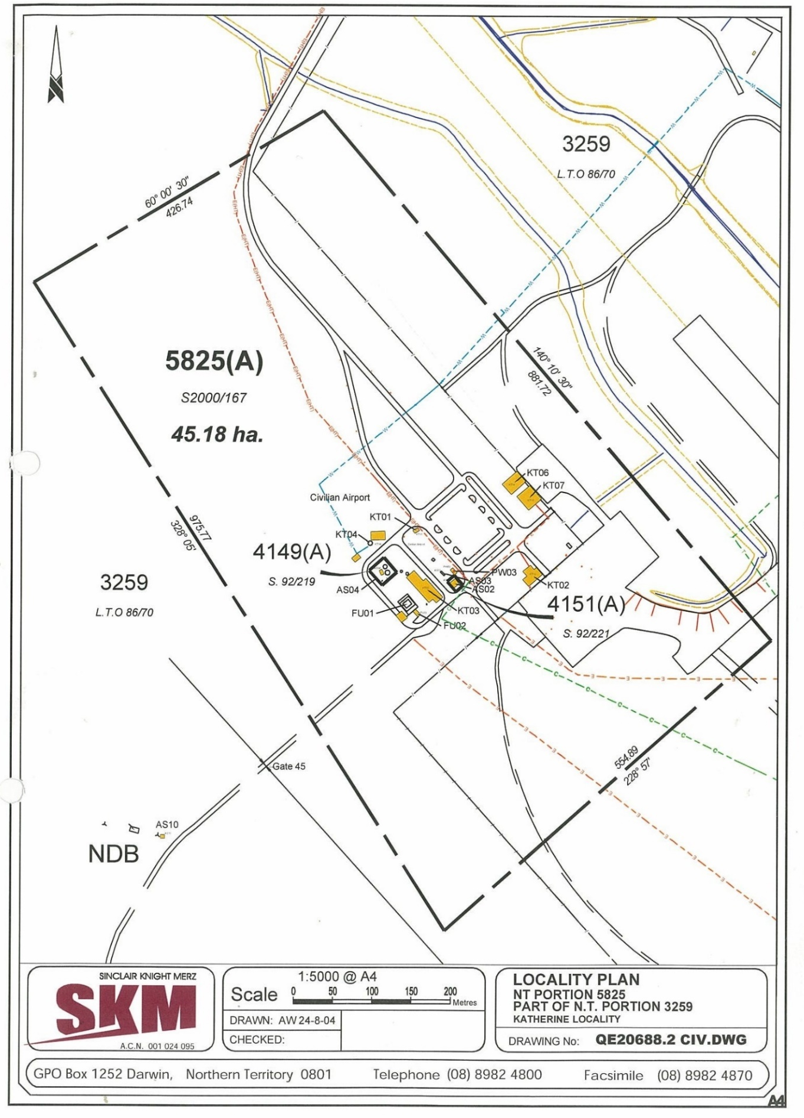
- KATHERINE CIVIL AIRPORT AERIAL VIEW

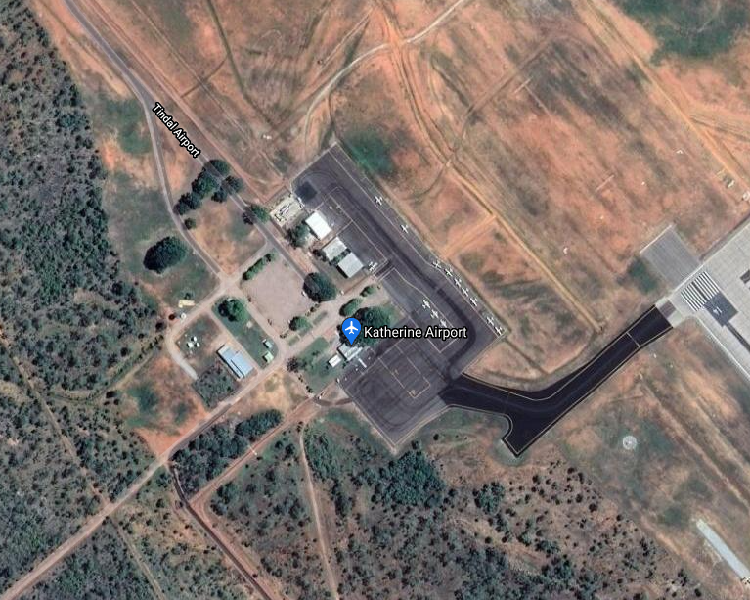
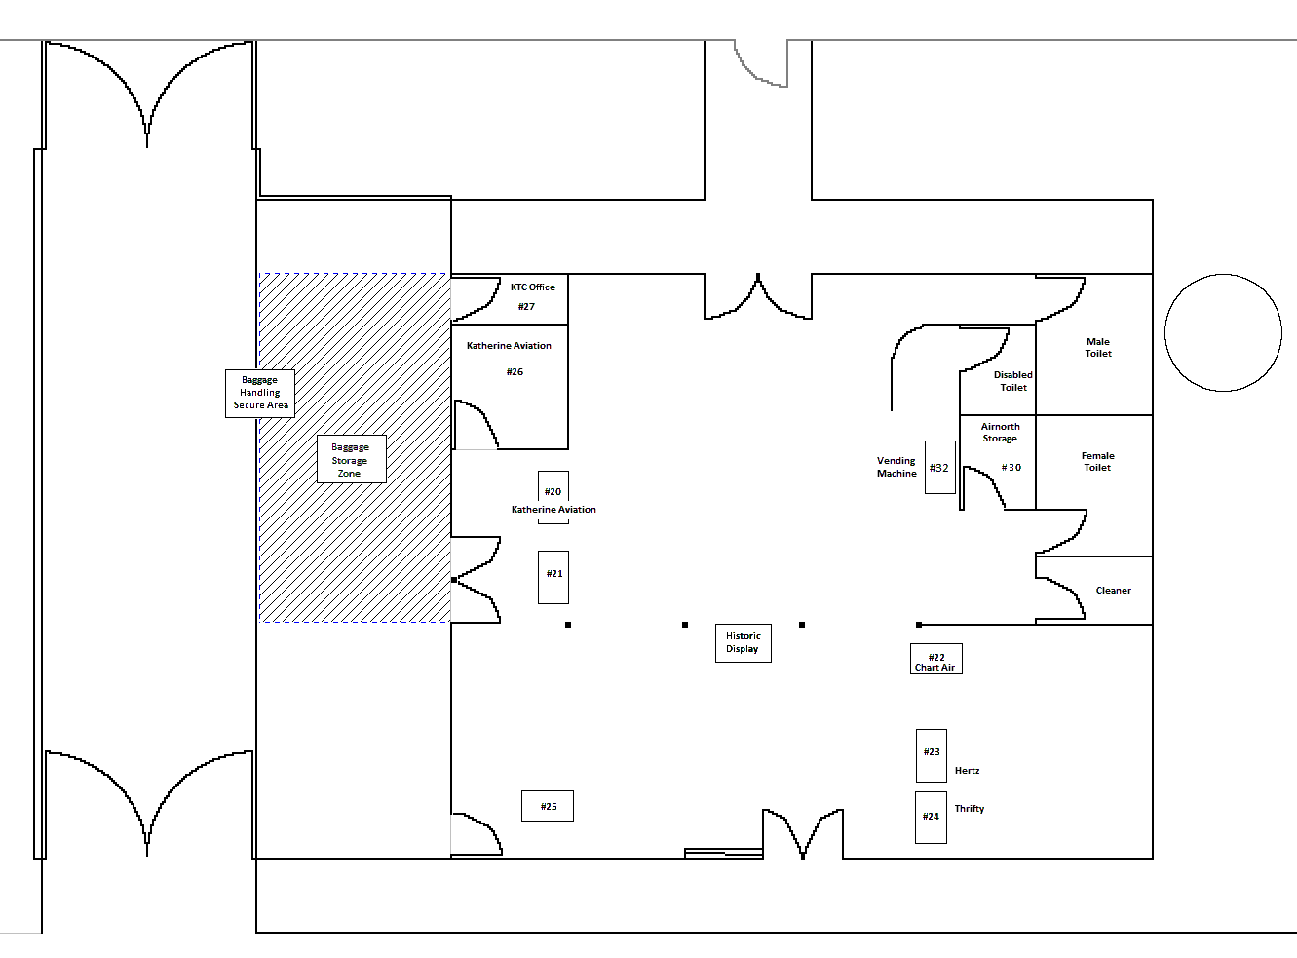
- KATHERINCE CIVIL AIRPORT TERMINAL BUILDING LAYOUT

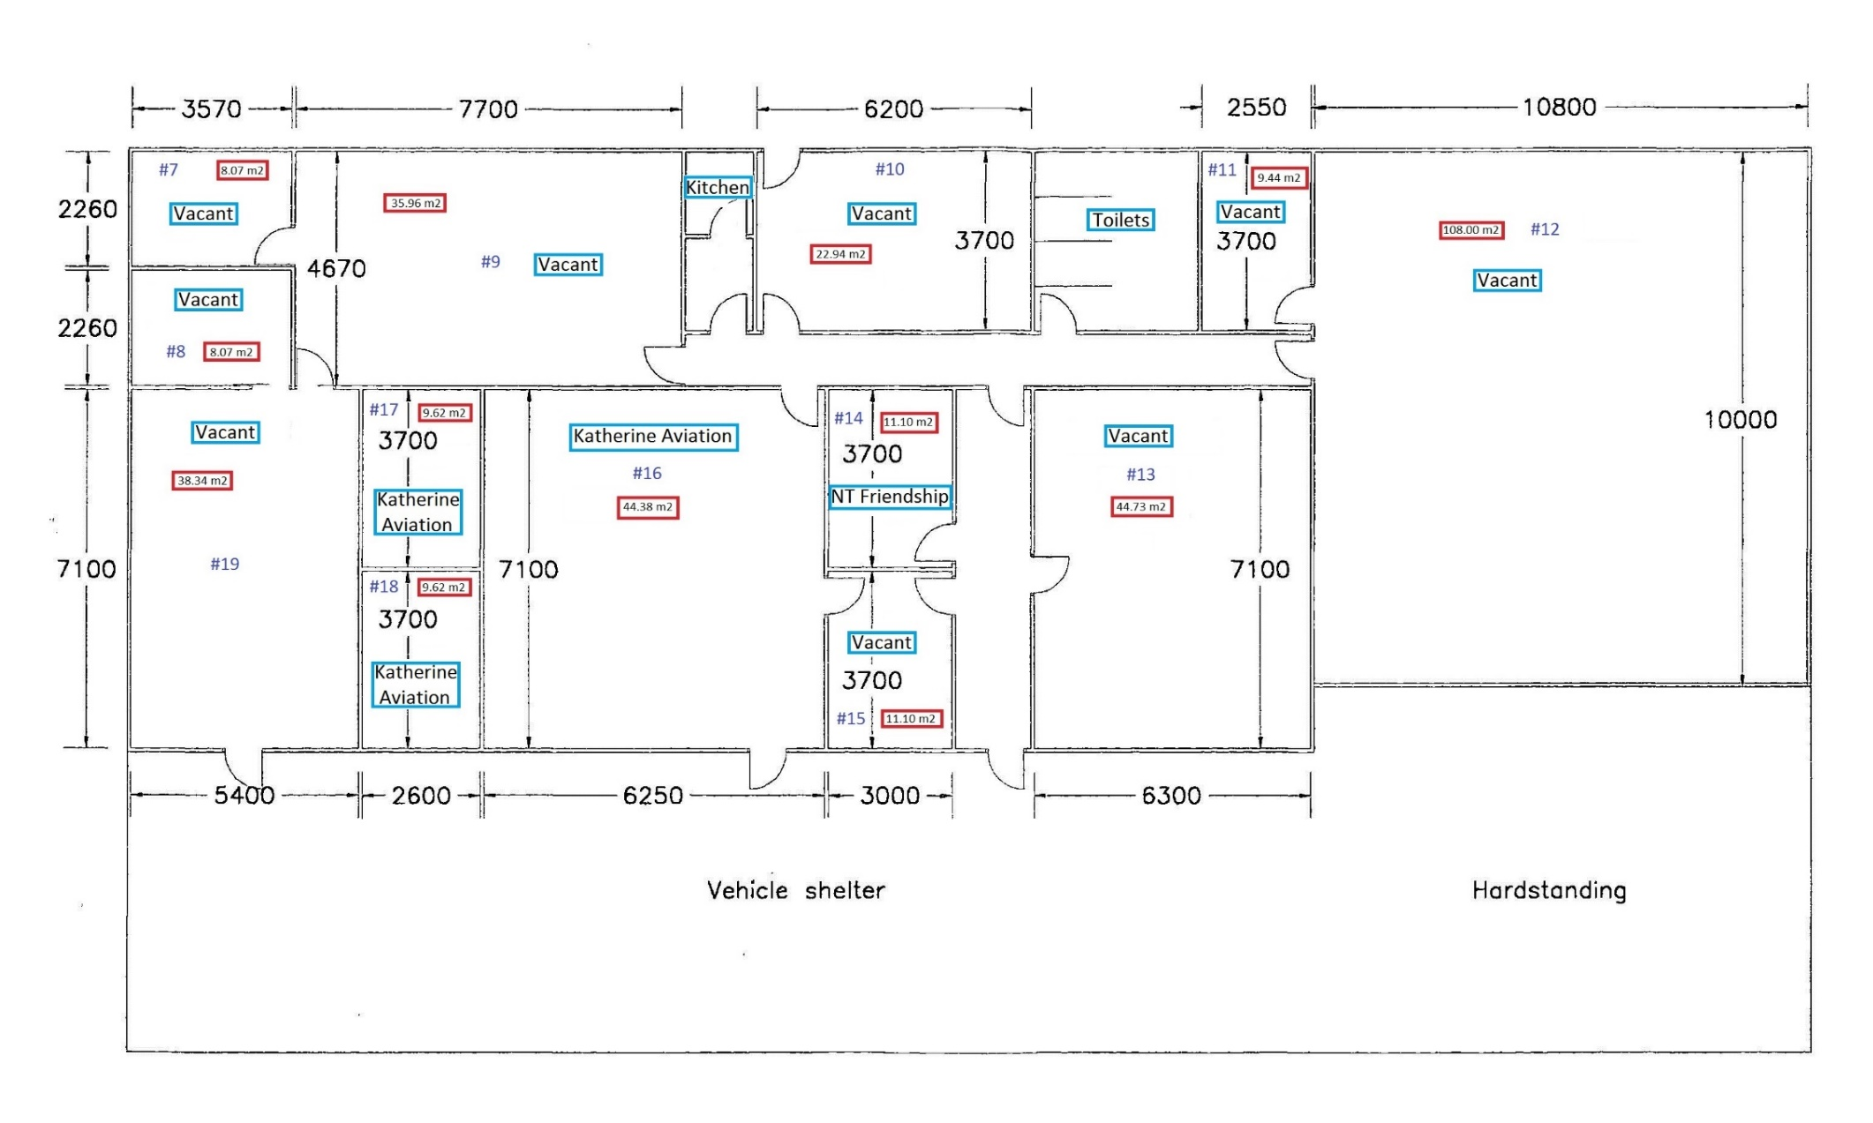
5. KATHERINE CIVIL AIRPORT ANCILLARY BUILDING AND WORKSHOP LAYOUT

