Tenders\Tenders 2020\T20-14 “EOI MANAGEMENT SERVICES FOR KATHERINE CIVIL AIRPORT”

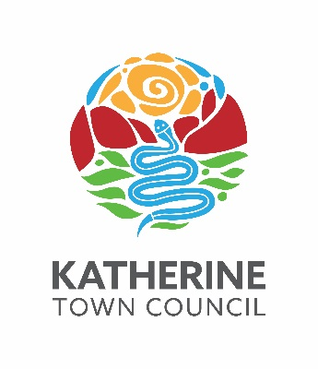

Transmittal

for

Katherine Town Council

ABN 47 836 889 865

regarding

Tender 20/14

“EXPRESSION OF INTEREST - MANAGEMENT SERVICES FOR KATHERINE CIVIL AIRPORT”

CLOSING

2pm, monDAY 31 may 2021

TENDER BOX KATHERINE CIVIC CENTRE, STUART HIGHWAY, KATHERINE

Tender 20/14

“EOI MANAGEMENT SERVICES FOR KATHERINE CIVIL AIRPORT”

Contract Documentation | Pages
T20-14 – Response Schedules – EOI Management Services for Katherine Civil Airport | 1 – 14
T20-14 – CoC v5.4 - EOI Management Services for Katherine Civil Airport | 1 – 31
T20-14 – EOI Management Services for Katherine Civil Airport | 1 – 28

ENQUIRIES:

Technical nature regarding the work required should be referred to:
- Director Infrastructure & Environment 08 8972 5500 or records@ktc.nt.gov.au

Tendering procedures or the like should be referred to:
- Director Corporate Services 08 8972 5500 or records@ktc.nt.gov.au

Tendering documentation requests to:
- Infrastructure & Environment Administration Officer 08 8972 5500 or records@ktc.nt.gov.au

